**Less water, more risk: exploring national and local water use patterns in the U.S.**

Joseph Kane

**Executive summary**

Frequently overlooked and taken for granted, water is not just vital for life; it also provides an economic foundation for millions of businesses, farms, manufacturers, and households that depend on a reliable supply each day. This foundational role puts considerable pressure on water utilities, which must maintain safe, efficient infrastructure and ensure that water is affordable for end users. Yet, in many areas across the United States, local leaders and residents do not consistently understand how much water they use or how their water demands connect to industrial change, population growth, and environmental stability.

This report provides a comprehensive comparison of metropolitan and nonmetropolitan water use patterns to help fill this information gap. It not only highlights the scale and complexity of how users in different areas depend on water, but also points to difficulties these users—and providers—face managing this scarce resource in an economically efficient and equitable way, alongside a growing list of physical infrastructure and natural environment concerns. It does so by analyzing water use data from the U.S. Geological Survey from more than 50 years to find that:

***A. Nearly 355 billion gallons of water are used each day in the United States, a total that has declined in recent years across a variety of categories.*** 90 percent of the country’s water withdrawals are concentrated in three categories of use—thermoelectric power, irrigation, and public supply—reaffirming water’s importance to a number of different industries and households nationally. Over the past few decades, however, water use has fallen by 42 billion gallons each day, in large part because of greater efficiency among these users.

***B. More than 221 billion gallons of water are used each day in metro areas, accounting for 63 percent of the U.S. total, but users in these areas tend to be more efficient than those in other parts of the country.*** As the centers of U.S. population and economic output, metro areas use the most water, including 80 percent of industrial use and 83 percent of public supply use. Just 25 of these metros, including New York, Chicago, and Washington, D.C., use 90 billion gallons of water per day, a quarter of the U.S. total. Nonetheless, users in these metros are much more efficient in their total water use (840 gallons per capita per day) than nonmetros (2,810 gallons per capita each day).

***C. From 1985 to 2010, water use in metro areas fell by 39 billion gallons each day, which drove almost 90 percent of the national decline during this period.*** As U.S. water use declined in recent decades, users in metro areas led the charge, particularly in the 100 largest metro areas, which reduced their use by 30 billion gallons a day. Aggregate use declined in nearly all major categories except public supply. Increasing public demand in many metro areas is challenging utilities to provide reliable, affordable water to a growing customer base.

***D. Several factors—including higher levels of energy and agricultural production, shares of developed land, and population densities—have a significant effect on water use within metro areas and nonmetro areas.*** When considering total water use, areas that generate more electricity, produce more crops, house more people, and contain more development tend to use more water, including many parts of California’s Central Valley. On the other hand, areas with higher population densities, shares of multi-unit housing, and compact forms of development tend to use less total water and residential water. Other characteristics, including housing values and certain resident demographics, also have significant effects.

While the U.S. is using less water and achieving greater water efficiency as a whole, many users, including power plants and agricultural producers, still require large amounts of water in specific areas, and utilities may be hard-pressed to implement infrastructure improvements in a timely, affordable fashion. In other words, traditional ways of managing scarce water resources are no longer sufficient to achieve long-term, dependable service and fiscal certainty. At a time when consumer demands are evolving, climate concerns are intensifying, and the need for greater technological innovation is growing, utilities and other local, state, and federal leaders must have a clearer assessment of the major environmental and economic risks at hand. By quantifying how water use is changing across different regions, this report creates a new starting point for these leaders to build on, where they can more consistently weigh risks to craft more efficient and equitable water infrastructure strategies.

**Introduction**

The United States faces a wide range of water infrastructure challenges, from aging pipes and outdated sewer systems to polluted waterways and degraded floodplains. The enormous variety of water infrastructure in need of repair and investment—with costs totaling up to $655 billion over the next 20 years—can be difficult to track at times, especially since many of these systems are out of sight and out of mind.[1] At the same time, the country is confronting a rising number of climate concerns and other physical pressures at these outmoded facilities, which face even more urgency and uncertainty after the U.S. withdrawal from the Paris Climate Agreement. Meanwhile, finding the skilled workers to carry out any improvements remains a significant impediment.[2]

These challenges are growing in frequency and intensity, often with significant environmental and economic ramifications.[3] Flint, Mich., is perhaps the most notable example in recent years, as many of its lower-income residents continue to grapple with water quality concerns stemming from its lead-tainted water system. Moreover, communities across California are slowly emerging from one of the most severe droughts in history, which has pressured households, businesses, and other agricultural producers to conserve water in ways never previously imagined. Many regions, from New York and New Jersey to Illinois and Indiana, are simply struggling to keep up with maintenance for their older water systems, as they operate under increasingly tight budgets and cope with water main breaks and other failures.

Given the magnitude of the country’s water infrastructure challenges, federal leaders are expressing heightened interest in new interventions. Both the Trump administration and Congress are considering options aimed at jump-starting water infrastructure investment on a national scale. However, a one-size-fits-all approach—based on the needs of only a few places or the U.S. as a whole—fails to capture the remarkable regional variety in water infrastructure governance, financing, design, and management across the country.

Instead, relying on more customized strategies that reflect state and local water needs can help define and ultimately deliver solutions to the country’s crumbling water infrastructure. Whether fixing leaking pipes, replacing lead service lines, or protecting vulnerable streams, localities stand at the front line of these challenges. Yet, addressing such challenges is difficult, as places struggle to quantify their needs, coordinate action, and assemble the plans and financial resources necessary to pursue different projects.[4]

This report aims to more consistently identify, measure, and assess infrastructure’s connection to broader economic priorities at a subnational level, by exploring how water is used at a metropolitan scale. Through several key metrics—including total water use and per capita water use—it provides a new starting point for metro and nonmetro leaders to consider while balancing water efficiency and equity considerations.

Depending on how water is used in a particular area, water utilities and other public- and private-sector leaders can face specific challenges—and risks—striving for improved environmental outcomes and meeting economic demands. When using water, industries look to optimize productivity and reduce waste, which is central to an efficient regional economy; likewise, utilities try to ensure that water is accessible and affordable to all users, which is central to an equitable regional economy. Steps toward greater efficiency are crucial, especially from an environmental standpoint, but leaders must also closely track how their water demands are changing in light of broader economic concerns, including equity. In this way, water is a vital natural resource to sustain life, ensure public health, and support a variety of other goals, but it is also an essential input to drive economic growth and opportunity.[5] Infrastructure is the key conduit to achieve this objective, yet it faces unique pressures in individual markets.

By examining how individuals and industries in metropolitan areas use water each day—from ordinary household uses to large-scale energy and agricultural uses—this report uncovers how these uses place specific demands on infrastructure, including declining levels of water use in many places that may be stressing utility finances. The report begins by defining and articulating the major types of infrastructure responsible for supplying water to different users and how these systems vary widely in their physical scope and investment needs. It then analyzes how water use varies in metro areas and nonmetro areas across the country, both in recent years and over the past few decades, to show how changing demands are prompting leaders to consider new management strategies. The report concludes with a discussion of what federal, state, and local leaders can do to support more efficient and equitable water infrastructure decisions in years to come.

**Background**

The following sections describe how the U.S. manages water and offer additional background on infrastructure’s complex role to serve different economic users throughout the country. The first section defines water infrastructure and what water use specifically entails in this report. Outlining the major challenges facing these facilities is the focus of the next section, including the need for greater investment despite the widespread fragmentation and difficulty coordinating action among utilities and other regional stakeholders. The last section discusses how these infrastructure concerns relate to a range of different economic users nationally, who may not always be able to clearly see how their water demands influence long-term infrastructure decisions. Together, these sections provide a foundation to better understand the patterns in metropolitan water use explored later in this report and ultimately inform what policymakers and practitioners need to consider when defining more efficient, equitable management strategies.

***What is water infrastructure?***

Water infrastructure spans several different manmade and natural systems that supply, treat, and conserve one of the most fundamental resources to communities and the environment.[6] These systems range from traditional gray infrastructure, such as pipes, pumps, and centralized treatment plants, to green infrastructure, such as rain gardens, bioswales, and other related natural assets that tend to be more decentralized.[7] In addition, rivers, lakes, ponds, wetlands, and subsurface aquifers are critical components of water infrastructure, as well as large manmade structures, such as aqueducts and levees.

This report focuses primarily on patterns of water use at a metropolitan scale, which tend to relate more directly to infrastructure that supplies and distributes water. As described more extensively in the report’s methodology section, “water use” broadly refers to any water withdrawn from the environment for a particular purpose, including residential, commercial, and industrial uses.[8] Anything from watering residential lawns to supplying water for office buildings to cooling power plant turbines is included.[9] In short, water is withdrawn from the ground and surface water sources, both freshwater and saline water, which is then transported, treated, and distributed through various infrastructure facilities to the end user.[10] As such, water use covers withdrawals in which water is diverted from a source but returned, generally in an altered state (such as power plant cooling), as well as consumptive water use in which water is removed and not necessarily returned to the source (such as water absorbed by plants or incorporated into industrial products).[11]

Water infrastructure, in turn, refers to all the transmission lines, treatment plants, storage facilities, distribution mains, and related assets required to move water from surface or groundwater sources, purify it to meet certain health standards, and provide it to users.[12] The physical extent of these infrastructure systems is massive, including 1.2 million miles of water supply mains, almost 26 times the length of the U.S. interstate highway network.[13]

***What challenges does water infrastructure face?***

The tremendous level of fragmentation across the country’s water infrastructure network means that metro leaders must confront a wide assortment of challenges all at once—in terms of governance, physical repairs, and financial concerns—which are not easy to track or address.

The U.S. relies on a number of federal, state, and local bodies to govern its water infrastructure, as illustrated in Box D later in this report. While many of these bodies coordinate with one another to oversee regulations, guide investments, and manage various infrastructure programs, plans, and projects, they also have a tendency to operate in silos.[14] Localities, in particular, often bear most of the responsibility of operating and maintaining the country’s water infrastructure, which can lead to struggles collaborating and developing plans across individual water systems.

Indeed, water infrastructure oversight is highly fractured. In total, more than 52,000 community water systems exist across the country—defined by the U.S. Environmental Protection Agency (EPA) as systems that supply water to the same population year-round.[15] Since these systems vary in scope and geographic reach, metro areas can have dozens, if not hundreds, of these systems stretching across their political boundaries and watersheds, with some systems serving only a few people and others serving hundreds of thousands of residents or other types of customers.[16] Still, of the nearly 300 million people served by community water systems nationally, a little over 400 systems (less than 1 percent of the country’s total number of community water systems) serve almost 140 million people (46 percent of the population).

**Figure 1. U.S. water infrastructure, by system size and population served**

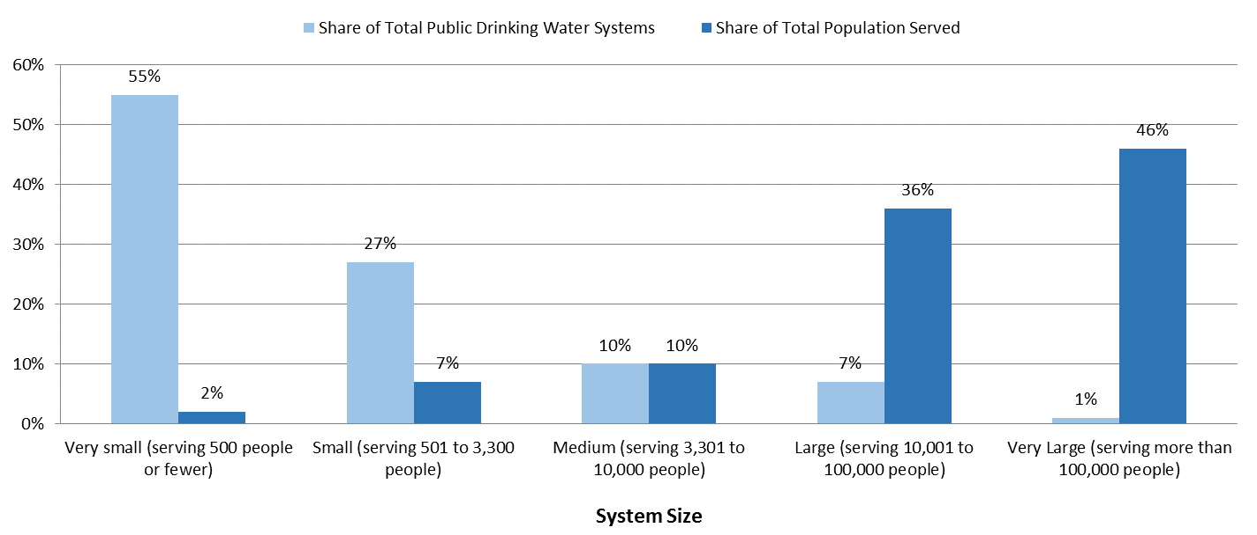

*Source: Brookings analysis of Environmental Protection Agency data*

In addition to different system sizes and functions, utility ownership varies from place to place, leading to different governance frameworks. Nearly 90 percent of the country’s population is served by water systems that are publicly owned by municipalities, counties, local regional authorities, and governmental districts, which include utilities such as DC Water and Denver Water.[17] However, the remaining 10 percent of the population is served by privately owned water systems, controlled by individuals or companies.[18] These include thousands of smaller systems (mobile home parks, for example) as well as bigger systems owned by large companies such as American Water.[19] Other types of arrangements, including public-private partnerships (PPPs), are also gaining interest depending on a particular system’s needs.[20]

Likewise, the specific source of water used can complicate how leaders in metro and nonmetro areas manage increasingly scarce or depleted supplies. Nearly 77 percent of all water withdrawals nationally come from surface water sources such as rivers, lakes, and reservoirs, but the remaining 23 percent come from groundwater sources, including aquifers.[21] While concerns over water quality and quantity may be more apparent in surface water sources, water is constantly moving above and below the Earth’s surface as part of the hydrologic cycle, which demands a more integrated look at surface water and groundwater issues together.[22] For instance, ensuring that ongoing agricultural and urban development does not overuse or contaminate groundwater resources is a key challenge for many regions. Steps toward additional water reuse—including wastewater recycling—are useful to consider in this way. Still, addressing larger surface water and groundwater issues together is challenging given the need to coordinate action among multiple stakeholders, often across jurisdictional and state lines.[23]

Beyond governance, the physical challenges are becoming more extreme as well; the pipes, plants, and other systems moving and treating water are near a breaking point in many regions. Years of deferred maintenance, inadequate funding, and other emerging challenges—including increases in population, urban development, and severe droughts and floods—have left systems struggling to provide clean, efficient, and equitable service.

According to EPA water needs surveys, up to $655 billion in infrastructure investments will be needed over the next 20 years, most of which would be due to replacing and refurbishing deteriorating transmission and distribution facilities.[24]This total surges even higher when considering climate change impacts.[25] Since many of these systems were built in the late 19th century through the mid-20th century, they are reaching the end of their useful life span.[26] Leaking pipes waste 2.1 trillion gallons of water each year, which includes treated water lost before even reaching end users.[27]At the same time, more than 2,000 water systems across all 50 states need to replace miles upon miles of lead pipes with excessive levels of contamination.[28] Additionally, 240,000 water main breaks occur each year in the U.S., costing $2.6 billion annually.[29]

The various physical needs do not fully illustrate the immense financial difficulties faced by individual utilities and other regional leaders who are striving to manage water in more cost-effective, sustainable ways.[30] These difficulties are particularly important to consider in achieving more economically efficient and equitable outcomes.

When it comes to **efficiency**, short-term construction projects focused on additional capacity remain important in some areas, but most of the country is in an era of repair and replacement, where service improvements and other upgrades are critical to spell long-term gains.[31] Yet, states and localities—the major players responsible for these repairs—are operating under limited budgets and may not have the flexibility or capacity to consider new alternatives, take on more debt, or use other financial tools, including new types of bonds.[32] Instead, some utilities are delaying projects or may choose lower-cost solutions, rather than investing in innovative engineering approaches and newer technologies.[33] Box B later in this report provides additional context to understand these challenges.

When it comes to **equity**, numerous utilities are struggling to address their most pressing projects and neighborhood-specific concerns, including water affordability. As highlighted in Box A, many regions are experiencing changes in the amount of water used, which is leading to unpredictable revenue streams for utilities that have traditionally relied on volumetric charges based on steady levels of demand.[34] Consequently, regions are realizing gains in water sustainability in many cases, but they are paying for infrastructure projects and making up for their revenue shortfalls by raising water rates up to 50 percent, which tends to hurt low-income households the most.[35] Amid these customer-facing affordability concerns, utilities are also struggling to recruit workers. The significant gap in hiring, training, and retaining skilled workers to manage systems is a pressing concern for utilities balancing multiple tasks.[36]

Combined, these issues pose several risks to the country’s water infrastructure, which cities, states, and their federal partners must address alongside other competing demands. Developing a more comprehensive, forward-looking approach to improve these interlocking systems of water infrastructure is not easy, but it is crucial to provide efficient, equitable service to millions of users nationwide.

**BOX A: The water equity challenge**

As users in metro and nonmetro areas alter their long-standing patterns of water use—traditionally defined by continued growth—utilities are facing new pressures to manage water. Surrounded by aging infrastructure, they must come up with more financial resources than ever to pay for repairs and manage the costs of service. Yet, they are dealing with greater uncertainty forecasting water demands, as many users are curbing their demand and becoming more efficient. The result: water rates are rising to maintain durable levels of revenue, but not all users can easily absorb these costs, leading to several equity concerns.

In general, utilities face two competing stresses: increasing costs to maintain and update deteriorating infrastructure, along with an expanding customer base that cannot afford rising utility bills. These come on top of several other pressing issues, such as regulatory compliance, public outreach, and increasing resiliency. As consumers fail to make payments or forgo services, other customers’ bills climb to cover the deficit, spawning a vicious feedback cycle.[37] Historically, utilities have reasonably juggled the two goals of revenue stability and equity, but continued gains in water efficiency and conservation have put many utilities in a tough position.[38] Household water bills, for instance, now have the potential to triple in some areas, simply to maintain minimum levels of service.[39] The struggle to balance efficiency and affordability, all while earning enough revenue to cover infrastructure needs, has resulted in a “conservation conundrum.”[40]

In this way, utilities are finding it increasingly difficult to provide reliable, affordable water, especially for certain households.[41] Low-income residential users are particularly sensitive to hikes in water prices because of the nature of the resource; water is an essential household commodity, and aside from curbing wasteful practices, demand remains relatively fixed. Increasing prices places a disparate burden on poor households, who cannot adjust the amount of water used for basic needs, whereas wealthier households fail to recognize the price signal and curb their excess consumption.[42] Small households of one or two members are especially vulnerable to rising water bills.[43] While water utilities continue to evaluate what rates are affordable for their customers, these efforts remain a work in progress, next to other infrastructure needs and regulatory concerns.

Meanwhile, federal affordability guidelines have attracted criticism from analysts who note that the challenge is likely larger than estimated. For example, when defining affordability for households, utilities normally follow the EPA’s “affordability criteria,” placing the standard at 4.5 percent of median household income for combined water and wastewater bills, which can overlook lower-income households.[44] Using this marker, census data suggest that these services are “unaffordable” for 23 million households,[45] and conservative estimates of rising rates suggest that the proportion of households with unaffordable bills could grow from 12 percent to nearly 36 percent in the next five years.[46] These increases come even as the cost of the average monthly combined water, wastewater, and stormwater bill in the U.S. has increased more than 41 percent since 2010.[47]

The extent of the investment and affordability crisis is extensive. Cities such as Austin, TX; Charlotte, N.C.; Chicago; San Francisco; and Tucson, Ariz., have all experienced water rate hikes of over 50 percent in the past five years, and some studies have predicted that water rates could quadruple over the next two decades.[48] This crisis is particularly apparent in Detroit, where a declining urban population has left fewer customers to pay for water.[49] To continue providing affordable water service for a range of customers, utilities must closely monitor how their water demands are changing and consider new revenue streams beyond increasing volumetric rates. Otherwise, the water equity challenge figures to become even worse.

***Who are water’s major users?***

The sizable geographic extent of the country’s water infrastructure underscores water’s importance to a variety of users and the economy. From farms in Nebraska to factories in Indiana to apartments in New York, water is an indispensable resource used to grow crops, manufacture products, fulfill household needs, and even generate electricity. As measured by the U.S. Geological Survey (USGS), the United States withdraws nearly 355 billion gallons of water each day across all uses.[50]

Based on USGS definitions, this report investigates water use across five major categories: thermoelectric power, irrigation, public supply, industrial, and other.[51]

**Major categories of water use**[52]

**Thermoelectric power** uses water to generate electricity from steam-driven turbine generators and for subsequent cooling processes.

**Irrigation** involves the controlled application of water for agricultural and horticultural purposes not satisfied by rainfall alone, including the use of systems to supply water to crops and other types of vegetation in golf courses, parks, and nurseries.

**Public supply** involves withdrawals by public and private water suppliers that provide water to at least 25 people or have a minimum of 15 connections, including residential, commercial, and industrial customers.

**Industrial** refers to water used as part of industrial and manufacturing activities, including fabrication, processing, and washing. Water in this category can be supplied by utilities, but only self-supplied withdrawals (that is, establishments that withdraw their own water) are examined separately in this report because of data limitations.

**Other** refers to a miscellaneous collection of smaller water uses, including livestock and aquaculture operations as well as mining activities.

Generating electricity tends to require the most water, particularly for **thermoelectric power** plants, which rely on fuels such as coal and natural gas to heat water and produce steam, which drives a turbine and creates power.[53] The primary demand for water in thermoelectric power plants, though, is for cooling water, which helps re-condense steam into water before the cycle is repeated.[54] Over time, these plants have transitioned from inefficient “once-through” cooling systems to more efficient “closed-loop” cooling systems, which recirculate and reuse water.[55] Still, there is more room for innovation in many regions, as researchers, planners, and other practitioners are exploring through a field of work that covers the “water-energy nexus.”[56]

Agriculture and horticulture also depend on extensive amounts of water, especially for **irrigation** when harvesting crops or supporting other types of vegetation.[57] Agricultural states with dry climates such as California and Texas tend to use more water for irrigation, increasingly from groundwater sources.[58] Ongoing drought conditions and water scarcity concerns, though, have prompted reassessments in irrigation and groundwater management, including advancements in irrigation methods, such as sprinkler irrigation, microirrigation, and surface systems.[59]

Beyond those industry-centric categories, water utilities manage and provide **public supply** water to all types of communities across the country, where residential customers account for most of these water deliveries.[60] On average, American families use more than 300 gallons of water per day at home, 70 percent of which tends to take place indoors and 30 percent outdoors.[61] As a result, utilities often face immense pressure to keep up with consumer demands, maintain assets, and provide clean, reliable service.[62] While doing so, they also act as major economic anchors in their communities. Public utilities invest $23 billion each year, contribute $52 billion in economic output, and employ 289,000 workers annually.[63]

In addition, direct **industrial** water use is critical for a variety of economic activities, including manufacturing. Commodities such as food and beverages, paper, and chemicals are among the major goods that depend on relatively large amounts of water, particularly in bigger manufacturing establishments.[64] Even the production of simple goods such as T-shirts can require 700 or more gallons of water each, from creating materials to diluting waste. [65] Consequently, exploring ways to improve efficiencies in these processes is a priority for many industries and researchers.

Finally, multiple **other** categories individually withdraw smaller amounts of water but further underscore water’s economic significance nationally. Water for livestock, aquaculture, mining, and self-supplied residential uses are captured here. Livestock withdrawals involve watering, feeding, and conducting dairy operations but do not necessarily capture the full “water footprint” of meat production, which is often closely tied to other agricultural activities.[66] Aquaculture involves the controlled harvesting and cultivating of fish and other aquatic organisms. Mining activities include quarrying and fracking, which have environmental and regulatory implications.[67] Self-supplied residential use generally involves private water sources, such as wells, which tend to be concentrated in rural areas.[68]

When viewed together, the categories described in this section highlight water’s diverse economic role nationally. Strengthening this role, however, requires an infrastructure network that can deliver water reliably, efficiently, and equitably. To support this network, metro and nonmetro leaders must have a more consistent and comprehensive sense of how their shifting water uses can influence steps toward greater innovation, revenue stability, and coordinated planning efforts.

**Methodology**

This report investigates patterns in U.S. water use by examining data from the USGS National Water-Use Science Project. The USGS provides the most comprehensive water use data set that is publicly available nationally, with estimates produced every five years from 1950 to 2010.[69] Estimates are available for individual states and the U.S. as a whole since 1950; however, county-level estimates also became available beginning in 1985, which allow for metropolitan and nonmetropolitan area aggregations.[70]

As noted earlier, this report follows USGS terminology and categories of analysis, described more extensively in the box at the end of this section. It focuses on water use—any water withdrawn from the environment for a particular purpose—across five categories: thermoelectric power, irrigation, public supply, industrial, and other. It does not exclusively or separately focus on consumptive water use, nor does it track levels of water reuse. While the USGS employs several different units of analysis to measure water use, including flow rates and land area, this report concentrates more exclusively on the amount of water used, or volume, which is expressed in the number of gallons used per day. This report does not separately examine trends in the sourcing of water (that is, groundwater versus surface water) or the quality of water used (freshwater versus saline water).

In addition, the report examines water use per capita—both total and residential[71]—to get a clearer sense of the relative amount of water used each day by individuals across different metropolitan areas. Per capita measures also provide insights into how efficient these uses can be over time; however, note that per capita changes may also result from different USGS estimation methods.

Although the USGS covers an extensive range of geographies and categories in estimating national water use over time, the most current data available from 2010, which do not capture the ever-evolving set of climate concerns, management strategies, and other changes that have taken place in the past few years. [72] With that said, this report analyzes water use across a host of different categories where consistency exists over time.[73] It not only outlines broader national trends from 1950 to 2010, but also explores subnational trends from 1985 to 2010. In particular, it examines patterns among metropolitan areas—defined as the country’s 381 metropolitan statistical areas (MSAs) according to the Office of Management and Budget (OMB)—while also considering patterns in nonmetropolitan areas outside these MSAs. For added detail, the report looks into water use patterns within the 100 most populated metro areas. When measuring changes over time, this report classifies MSAs and related counties based on the most recent OMB definitions.

Lastly, the report examines subnational water use in terms of several variables of interest to better understand some of the underlying factors behind regional variation. Specifically, it uses an ordinary least squares (OLS) multiple regression to investigate the association between these variables and county-level water use. It uses two OLS models to do so; one model explores total water use in relation to several industrial, environmental, and spatial variables, while the other model explores residential water use in relation to several household and demographic variables. The models are based on a single year of data from 2010. Further information on these models is in Appendix A.

**Key terms**:[74]

**Water use**:The total amount of water withdrawn from the environment for a particular purpose, including for a host of residential, commercial, and industrial uses. It does not exclusively or separately focus on consumptive uses. An all-encompassing term, it spans withdrawals, deliveries, and self-supplied water. It is measured in the number of gallons used each day.

**Water use per capita**:The amount of water used, divided by population. This report considers both “total water use per capita” (total water use divided by population) and “residential water use per capita” (residential water use divided by population) to help gauge how efficiently water is used across different parts of the country. It is measured in the number of gallons used each day per individual.

**Withdrawals**:Water removed from the ground or diverted from a surface-water source for use. Withdrawals can involve deliveries to the end user or be self-supplied. They are measured in the number of gallons used each day.

**Deliveries of water**:The amount of water that is withdrawn and ultimately delivered from a public supplier to end users, which may include conveyance losses. They are measured in the number of gallons used each day.

**Self-supplied water**:The amount of water that is withdrawn by a user—via a well or other source—rather than being obtained from a public supplier. It is measured in the number of gallons used each day.

**Consumption**:The portion of withdrawn water that is evaporated, transpired, or incorporated into a product or plant, and not necessarily returned to the original source for immediate use.This report does not analyze consumptive water use separately.[75]

**Metropolitan water use**:The amount of water used in a metropolitan statistical area (MSA), as defined by the Office of Management and Budget (OMB). These include the 100 largest (or most populated) MSAs and 281 smaller MSAs. This term can refer to total metro water use, in addition to metro water use across other individual categories (irrigation, residential, etc.). It is measured in the number of gallons used each day.

**Nonmetropolitan water use**:The amount of water used in areas outside MSAs. These include rural areas and smaller micropolitan statistical areas. Similar to metro water use, nonmetro water use is analyzed in total terms and across other individual categories. It is measured in the number of gallons used each day.

**Findings**

1. *Nearly 355 billion gallons of water are used each day in the United States, a total that has declined in recent years across a variety of categories.*

Water represents not only a basic service to sustain life, but also an essential input to drive economic activity. The U.S. uses nearly 355 billion gallons of water each day. The two largest categories of water use—thermoelectric power (161 billion gallons) and irrigation (115 billion gallons)—together account for almost 78 percent of this national total. Public supply use comes next at 42 billion gallons, or 12 percent, which includes deliveries to most of the country’s residential customers. The remaining 10 percent is split among industrial water use (16 billion gallons) and a miscellaneous assortment of other uses (20 billion gallons), including mining, livestock, aquaculture, and self-supplied-residential water use.

**Figure 2. U.S. water use, by category, 2010 (billions of gallons each day)**

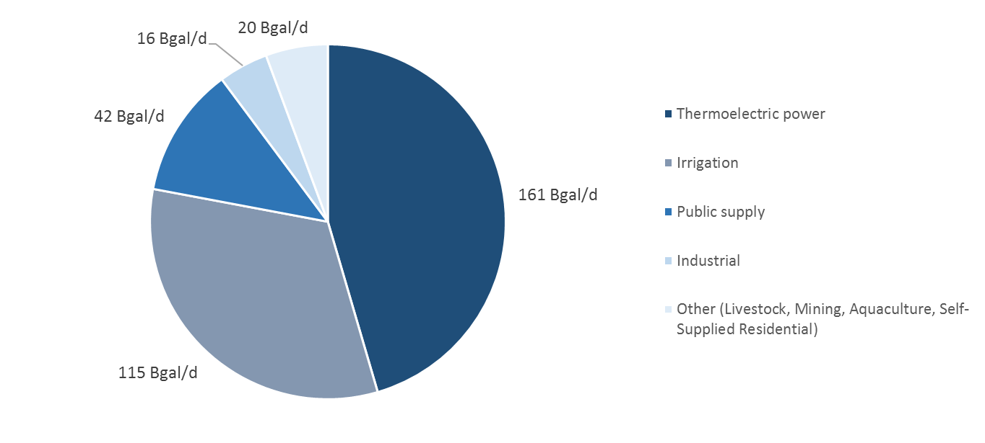

*Source: Brookings analysis of USGS data*

Despite the enormous amount of water used across the country, the U.S. experienced an overall decline in these levels over the past few decades. From 1985 to 2010, water use fell by 42 billion gallons each day—from 397 billion gallons to 355 billion gallons, an 11 percent decline. From 2000 to 2010, this pattern accelerated, with a 14 percent reduction. Although the U.S. is using nearly twice the amount of water than it did each day in 1950—355 billion gallons compared with 180 billion—this increase has been more uneven compared with the country’s steady climbs in population and rapid jumps in economic output in the same period. For instance, population more than doubled, while real gross domestic product (GDP) nearly septupled.

**Figure 3. Changes in U.S. water use, population, and real GDP, relative to 1950 levels**

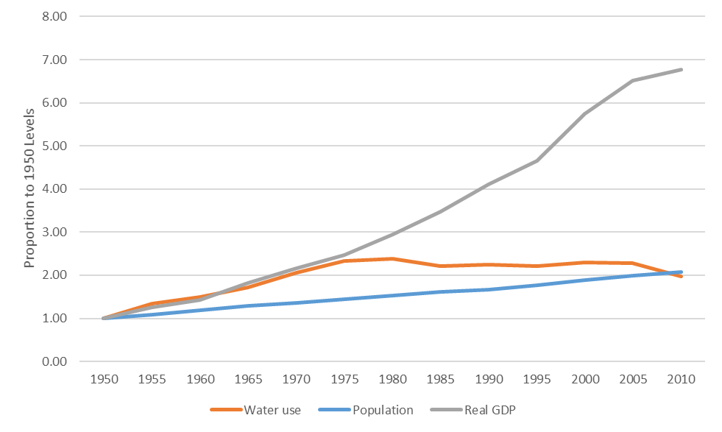

*Source: Brookings analysis of USGS (water use), census (population), and Bureau of Economic Analysis (real GDP) data*

Declines in water use appear across several major categories, as shown in Figure 4. From 1985 to 2000, withdrawals for thermoelectric power and irrigation fell by 26 billion gallons and 20 billion gallons each day, respectively, equal to about a 14 percent reduction in water use. From 2000 to 2010, the same two categories declined 17 percent, driving most of the overall declines at a national level. On the other hand, public supply withdrawals represent the only major category that generally had aggregate increases in water use, likely tied to the nation’s growing population. Since 1950, public supply withdrawals tripled—from 14 billion gallons each day to 42 billion—and since 1985, they surged by more than 5 billion gallons each day, a 15 percent increase. However, public supply use tailed off slightly from 2005 to 2010, declining 5 percent despite continued U.S. population growth.

**Figure 4. Changes in U.S. water use, by selected categories, 1950 to 2010**

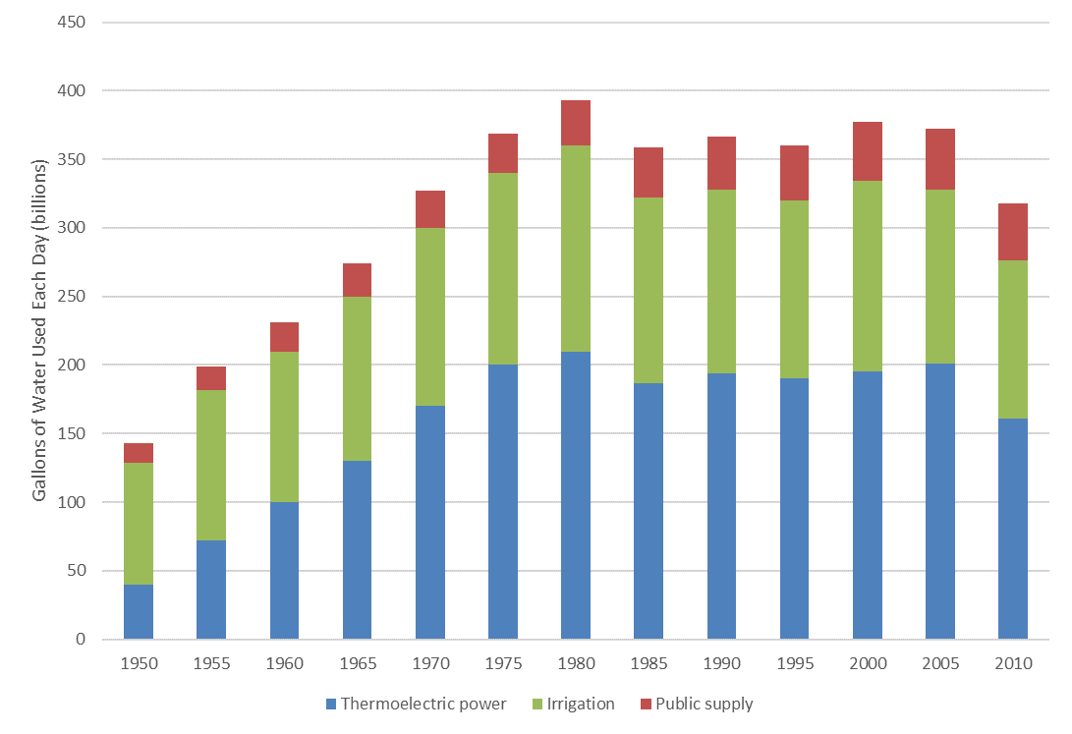

*Source: Brookings analysis of USGS data*

Although public supply withdrawals—including deliveries to residences—grew in importance over the past few decades, the nation became much more efficient in its water use, especially on a per capita basis. From 1985 to 2010, U.S. population increased by 29 percent, but total water use declined by 11 percent; in turn, total water use per capita fell from 1,640 gallons each day to 1,130. A closer look at how residences adjusted their use reveals a similar trend. Since 1985, residential water use per capita fell from 101 gallons a day to 88, potentially reflecting how many households adopted conservation measures and used more efficient appliances and other technologies.[76] Still, additional steps to improve water efficiency remain a key concern for utilities and other leaders. Box B outlines the various environmental and technological factors involved in solving this challenge.

**BOX B: Water disruptions and innovations**

While the U.S. already contends with a number of barriers to make more efficient and equitable infrastructure decisions, a variety of environmental pressures and technological changes add even more urgency to this challenge.

The threat of climate change poses severe risks for water utilities and users alike.[77] The rising uncertainty associated with floods, droughts, and related climate concerns are altering the ways in which places manage and use water, including the need to adopt long-term planning strategies rather than reacting with short-term fixes.[78]These concerns are not isolated to one region, either. While extreme drought conditions in the West continue to dominate national headlines, water shortages have also occurred in places like New York City and Philadelphia in recent years.[79]Over the next decade, 40 of 50 states will experience water shortages to some degree.[80]In addition, the population continues to surge in many drought-stricken and flood-prone areas nationally.[81]

To boost resilience and provide greater economic certainty, leaders in many places are creating new plans and forming new collaborations, but doing so is not always easy. From green infrastructure investments[82] to water resilience programs,[83] these efforts often mark a departure from previous ways of designing and delivering projects. In California and other water-scarce regions, new conservation strategies such as water use restrictions on urban customers and incentives for water reuse and recycling are now online.[84] Conservation programs will continue to become the norm, as precipitation patterns, temperatures, and other climatic factors affect the availability of water.[85] Other methods will play a role as well, including new pricing schemes, which may not be easy to implement quickly depending on particular system needs.[86]

Utilities and industries are also emphasizing water efficiency technologies to respond to these stresses. These include better leak detection, pipe condition assessment, and pressure management. Some areas are also looking into water reuse and desalination.For metros grappling with long-term water supply concerns, such as San Diego, recycling treated wastewater rather than discharging it into coastal waters could significantly augment available water sources.[87] At least 32 states have regulations in place to allow forms of reuse, including Florida, California, Texas, and Arizona.[88]Likewise,seawater and brackish water can be treated to remove dissolved salts and other substances to become potable through desalination, although concerns exist over cost and energy use.[89]

For the most part, however, the development of and investment in new water technologies remain lackluster.[90] Budget constraints and a lack of political urgency have restrained capital expenditure on research and development on water infrastructure. Water technologies are at a competitive disadvantage in an already difficult venture capital market because of few groundbreaking discoveries, problems integrating into existing systems, and an inability to scale up effectively.[91]As Figure 5 shows, the number of water and wastewater patents issued nationally has lagged compared with several other clean tech categories since 2001, averaging under 2 percent annual growth over this span.[92] The same proves true for venture capital (VC) investment; water and wastewater VC investment fell by $100 million from 2011 to 2016, alongside other precipitous declines in energy efficiency.[93]

**Figure 5. Number of clean tech patents issued in the U.S., across selected categories, 2001 to 2016**

*Source: Brookings analysis of IP Checkups’ Cleantech PatentEdge database*

Perhaps more importantly, even though supporting environmentally resilient and technologically efficient infrastructure systems is increasing in importance, many utilities and other leaders nationally are struggling to implement upgrades. While the inability to pay for these improvements and the lack of clear regulatory frameworks to encourage them represent two major impediments, some water users and providers may not even know where to start, geographically or otherwise.[94] With a better understanding of infrastructure needs and a clearer identification of economic priorities, though, metro areas can forge water management strategies that are more responsive to innovation.

1. *More than 221 billion gallons of water are used each day in metro areas, accounting for 63 percent of the U.S. total, but users in these areas tend to be more efficient than those in other parts of the country.*

National water use patterns broadly depict how households, businesses, and other economic actors depend on water each day. Yet, these patterns do not reveal how different places across the U.S. can vary widely in their water needs or how efficiently they use water. Examining how metro areas and nonmetro areas vary in their patterns of water use offers a clearer view into the unique infrastructure pressures that different areas face and the importance of considering trends from a more regional perspective.

As the centers of U.S. population (85 percent) and economic activity (88 percent of GDP), metro areas also account for most of the country’s water use (63 percent).[95] The 221 billion gallons of water used each day in metro areas include the bulk of the country’s withdrawals: from thermoelectric power (76 percent) to industrial (80 percent) to public supply (83 percent). Not surprisingly, the only categories in which users in metro areas do not account for the majority of water use are irrigation (41 percent) and other (mining, livestock, aquaculture, and self-supplied) uses at 37 percent.

**Figure 6. Metro and nonmetro shares of U.S. water use, by category, 2010**

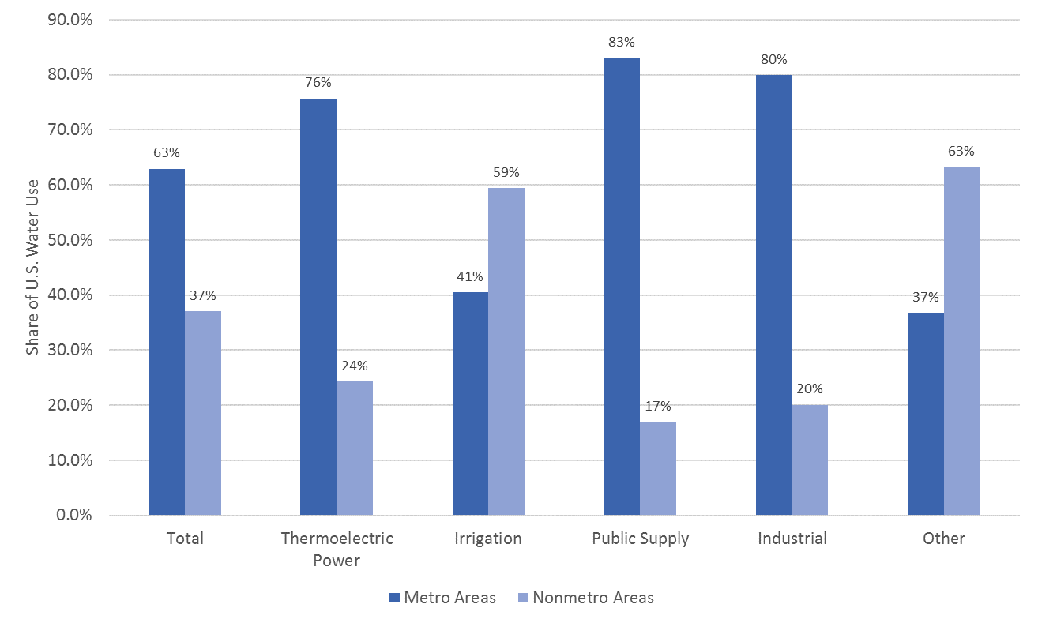

*Source: Brookings analysis of USGS data*

While metro areas and nonmetro areas play considerably different roles, there are also fundamental differences *within* each of these two geographies.

First, users in the most populated metro areas tend to have the greatest impact on national water use. As shown in Table 1, users in the 100 largest metro areas depend on almost 136 billion gallons of water each day, which accounts for 62 percent of the all-metro total and 39 percent of the U.S. total. They also exceed the entire nonmetro total (130 billion gallons each day). Their public supply withdrawals (27 billion gallons per day) rank among the highest nationally, responsible for nearly two-thirds of the U.S. total. Their withdrawals for thermoelectric power (77 billion gallons a day) and industrial uses (8 billion gallons a day) are quite sizable as well, each making up about half of the U.S. totals in these two categories.

**Table 1. Water use totals, by geography and category, 2010 (billions of gallons each day)**



*\*“Rural areas” refers to counties not contained in a metropolitan statistical area or micropolitan area.*

*\*\*Aggregated U.S. totals shown here may deviate from other reported USGS totals because of rounding.*

*Source: Brookings analysis of USGS data*

Second, users in metro and nonmetro areas depend on water in different ways. As Figure 7 illustrates, more than half of total water use (54 percent) in metro areas—almost 120 billion gallons each day—goes toward thermoelectric power, versus 30 percent in nonmetro areas. Withdrawals for irrigation are sizable in metro areas (21 percent), but they are especially important in nonmetro areas (53 percent). In addition, the higher populations in metro areas mean that public supply water use plays a bigger role (16 percent) than it does in nonmetro areas (5 percent). As a result, improvements in irrigation technology are likely to make a bigger difference in aggregate terms in nonmetro areas, while efforts to improve household water efficiency are likely to spell bigger gains in metro areas. Energy efficiency is paramount, regardless of geography.

**Figure 7. Water use shares within metro areas and nonmetro areas, by category, 2010**

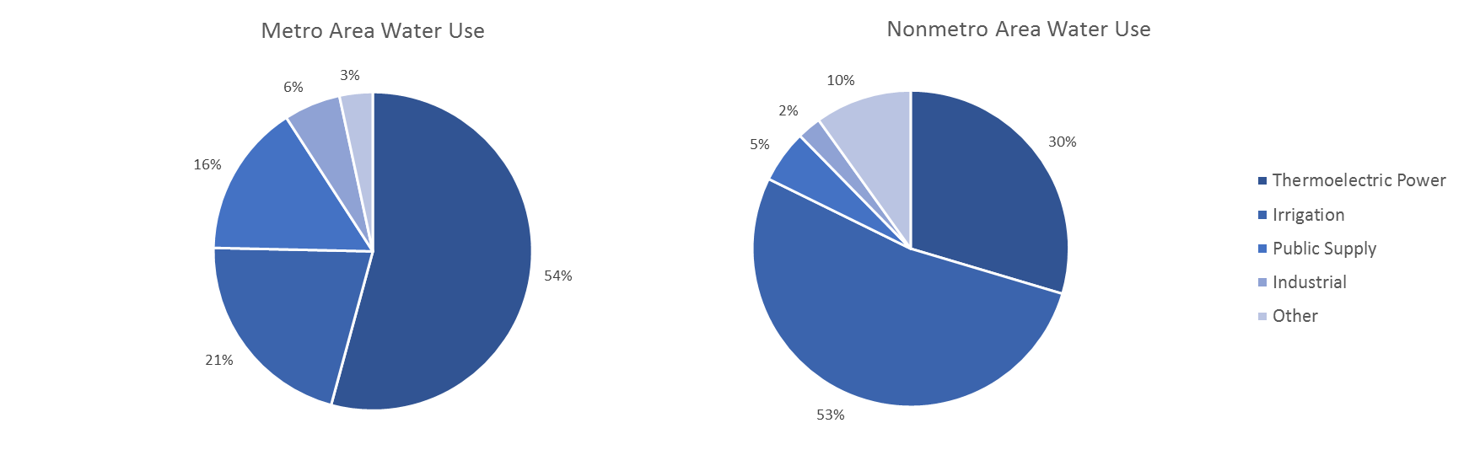

*Source: Brookings analysis of USGS data*

Third, per capita water use differs markedly between metro and nonmetro areas. Water use in metro areas totals 840 gallons per capita each day, less than one-third the per capita rate of 2,810 gallons in nonmetro areas. The difference is even starker when compared with the 100 largest metro areas, which have a total water use per capita of 670 gallons each day. It is important to note, however, that much of this total variation is heavily influenced by the lopsided irrigation withdrawals in nonmetro areas. For example, in terms of residential water use per capita, metro and nonmetro areas are both near the national average of 89 gallons each day. In other words, while large energy and agricultural users can lead to enormous differences in total water use per capita at a metro scale, most households are using water in similar amounts nationally and residential water use per capita is more consistent.

Together, these differences in metro and nonmetro water use come into greater focus when comparing specific places across the country. For instance, as shown in Figure 8, users in the biggest metro areas such as Chicago, New York, and Washington, D.C., depend on the most water; the 25 metro areas with the most water use nationally depend on more than 90 billion gallons each day, equal to a quarter of the U.S. total. In many of these metro areas, withdrawals for thermoelectric power and public supply are especially significant, including in places such as Charlotte, N.C.; Tampa, Fla.; and St. Louis, where these two categories alone account for more than 95 percent of their total water use.[96] Agriculturally focused metros such as Fresno and Stockton, California, stand out along the relative measure given their widespread irrigation activities.

**Figure 8. Water use in the 100 largest metro areas, total and per capita, 2010**

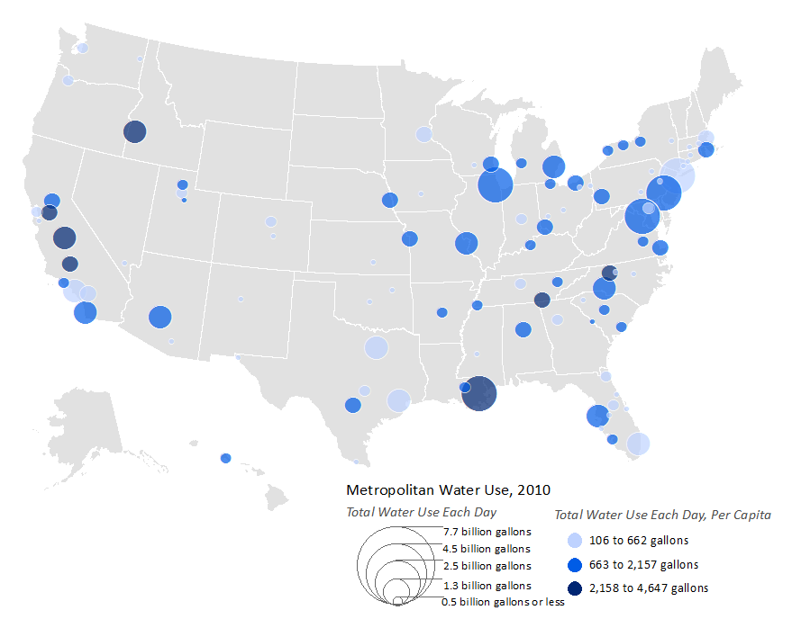

*Source: Brookings analysis of USGS data*

Although users in metro areas depend on sizable amounts of water, they are generally more efficient than users in nonmetro areas, primarily because of their less water-intensive economic activities. From New Haven, Conn., to Colorado Springs, Colo., users in many of the country’s largest metro areas not only use under 200 gallons of total water per capita each day, but also use under 75 gallons of residential water per capita each day—which are both well under the national averages. However, there are several exceptions, namely in places with higher withdrawals for thermoelectric power and irrigation relative to their population. This is the case in metro areas such as Chattanooga, Tenn., and New Orleans, where large thermoelectric power withdrawals take place and total water use per capita exceeds 3,750 gallons each day.[97] The range of water uses across metro areas and nonmetro areas, in turn, requires targeted management strategies to realize additional gains in efficiency.

1. *From 1985 to 2010, total water use in metro areas fell by 39 billion gallons each day, which drove almost 90 percent of the national decline during this period.*

Over the past few decades, water use in metro and nonmetro areas reflected larger national trends, where many industries and other users reduced their withdrawals. However, the pace at which these declines occurred varied widely from place to place. For example, while total water use in the country as a whole fell by 42 billion gallons each day (11 percent) from 1985 to 2010, metro areas experienced a decline of 39 billion gallons per day (15 percent), to 221 billion. Nonmetro areas, on the other hand, reduced their water use by only about 3 percent.[98] Many of these declines took place over the past five to 10 years, largely driven by metro areas as shown in Figure 9.

**Figure 9. Changes in metro and nonmetro total water use, 1985 to 2010**

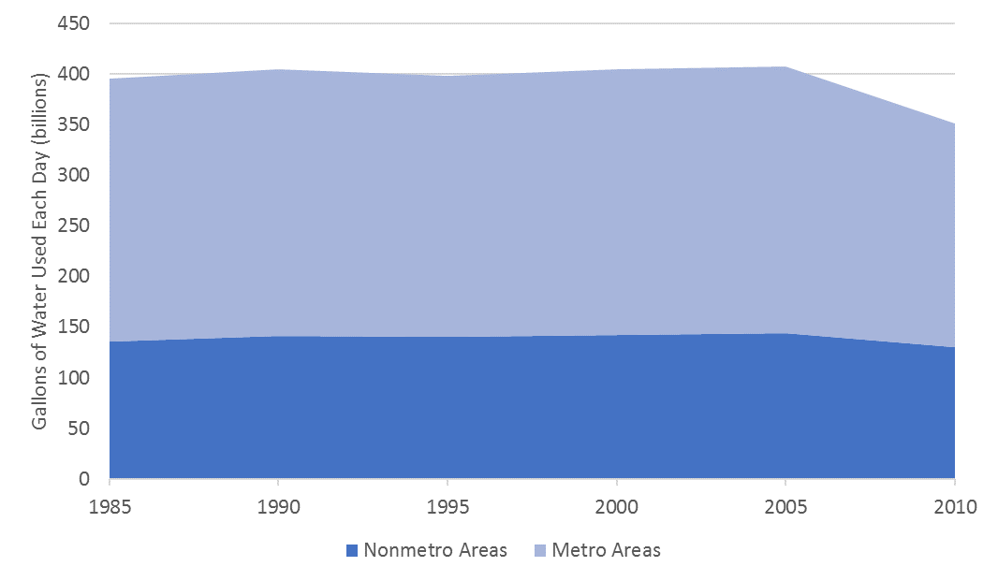

*Note: Aggregated U.S. totals shown here may deviate from other reported USGS totals, because of rounding and suppressions.*

*Source: Brookings analysis of USGS data*

Users in the 100 largest metro areas generated the largest aggregate decreases. From 1985 to 2010, they reduced their total water withdrawals by 30 billion gallons each day to 136 billion gallons—an 18 percent decline. Consequently, they were responsible for more than 71 percent of the total national decline over this period—30 billion gallons out of 42 billion—despite continuing to account for only about 40 percent of all U.S. water use. In other words, these large metro areas are playing an outsized role in reducing the country’s total water use.

Since 1985, metro and nonmetro areas experienced declines across all types of water categories, with one notable exception: public supply. As Figure 10 shows, metro and nonmetro withdrawals for thermoelectric power and irrigation fell about 15 percent, in the same direction as national trends. Industrial withdrawals dropped nearly 40 percent—a precipitous decline perhaps indicative of more advanced technologies being used in manufacturing processes, among other changes. As the country’s population grows, though, public supply withdrawals are rising in both metro and nonmetro areas, up to 22 percent since 1985. More recently, since 2005, public supply withdrawals nationally declined slightly, but population gains in many places are still stressing utilities to provide efficient and equitable water to a growing customer base.

**Figure 10. Percentage change in metro, nonmetro, and U.S. water use, by category, 1985 to 2010**

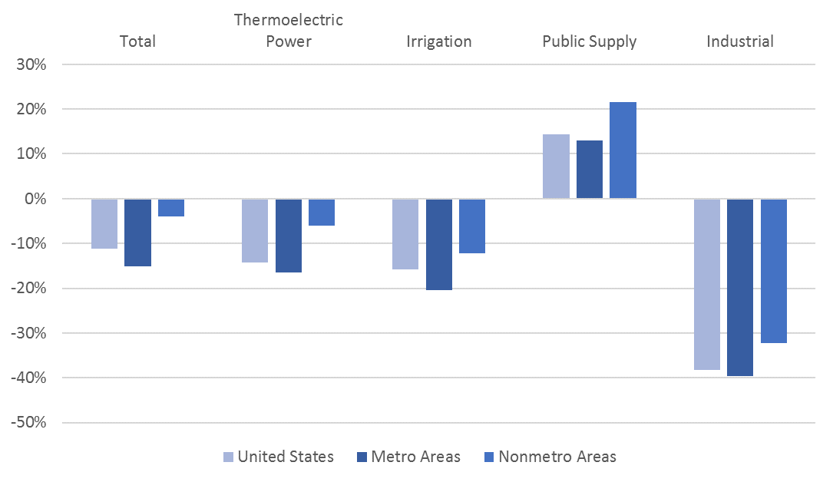

*Note that “other” water withdrawals are not included because of category changes over time.*

*Source: Brookings analysis of USGS data*

As users in metro areas and nonmetro areas depend on less water, they are also becoming more efficient. From 1985 to 2010, water use per capita in metro areas declined 480 gallons each day (36 percent) from 1,320 gallons to 840, while nonmetro areas had a slightly smaller reduction of 420 gallons per day (13 percent), from 3,230 gallons to 2,810. The implementation of new technologies likely influenced these numbers, particularly in thermoelectric power plants and various agricultural industries. In terms of residential water use per capita, metro areas fell 14 gallons each day to 88 gallons, while nonmetro areas declined 8 gallons a day, to 86. The use of new appliances and other behavioral changes potentially played a role at a household level.

Certain metro and nonmetro areas, of course, are driving these trends. Since most declines occurred from 2005 to 2010, these recent water use patterns offer clearer insight into the types of economic shifts taking place in specific markets—and what those shifts might mean for their infrastructure.[99]

Figure 11 displays how some of these trends have played out among different metro areas. In total, users in 74 of the 100 largest metro areas reduced their water use from 2005 to 2010, using 293 million gallons less each day on average. Led by bigger markets such as New York, Miami, and San Diego, many of the declines resulted from falling thermoelectric power withdrawals of up to 1 billion gallons per day.[100] Among the exceptions are metro areas with faster-growing populations such as Seattle and Denver, although steps toward less water use are starting to take hold in many of these places as well.[101] Beyond declines in total water use, one of the bigger and more consistent patterns taking place in most metro areas has been improved water efficiency. Total water use per capita fell in 81 of the 100 largest metro areas over these five years, while residential water use per capita fell in 65 of these metro areas, anywhere from Syracuse, N.Y., to San Antonio, TX. In many ways, these metro-specific changes reflect national trends, but they also point to questions over what factors are leading to such regional variation.

**Figure 11. Changes in total water use among the 100 largest metro areas, 2005 to 2010**

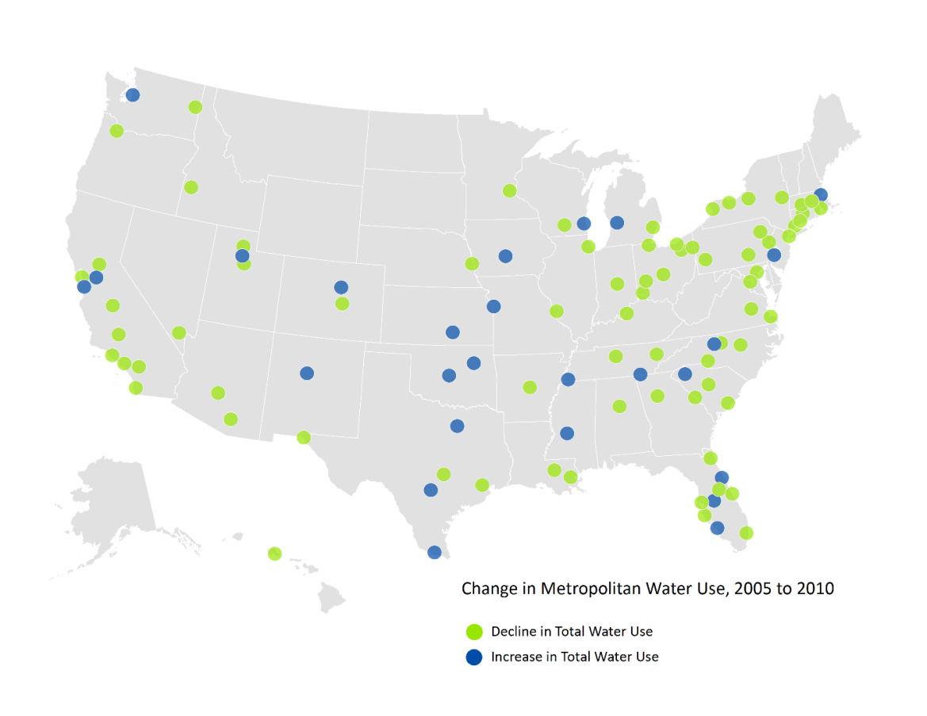

*Source: Brookings analysis of USGS data*

1. *Several factors—including higher levels of energy and agricultural production, shares of developed land, and population densities—have a significant effect on water use within metro and nonmetro areas.*

Understanding why users in some places—including particular cities and neighborhoods—depend on more water than others has attracted considerable attention from academics and practitioners. Typically, through household surveys and other methods, research has pointed to several economic, environmental, and demographic factors potentially explaining this variation (Box C). Yet, it can be difficult to draw any definitive conclusions given the relatively narrow geographic scope of many of these studies, the lack of consistent data, and the complicated set of concerns managing water across different regions, which may not always be easy to quantify.[102]

**BOX C: What factors tend to affect water use?**

Water use at national, state, and local levels varies for a host of reasons, attracting interest from policymakers, planners, and researchers. Typically, analyses focused on specific categories of use, such as residential or industrial, to more precisely define the set of factors that may affect a particular geography.[103] Demographic and housing unit characteristics, for instance, are frequently linked to variations in residential use, while an assortment of technological and environmental characteristics are often examined in relation to broader water use patterns. Based on this work, researchers point to several common variables that tend to significantly affect water use.

A number of economic and environmental factors are generally associated with total water use in a given locality. The **types of industries present**, particularly large energy and agricultural operations, can result in a greater need for water as an input to drive production.[104] Likewise, the level of **urban development** and the specific type of **population distribution (or density)** in a region can influence water demand.[105] Certain climatological conditions can also play a role. Lower levels of **precipitation**, for instance, can increase watering needs for farms, businesses, and households while placing more pressure on water utilities to deliver water, even during times of drought.[106] Similarly, higher **temperatures** increase the need for plant watering and other outdoor uses.[107] Finally, climate change is predicted to intensify **evapotranspiration** of water used for landscape maintenance and agricultural irrigation, heightening water demand.[108]

Residential water use, while affected by many of those same factors, can also vary depending on demographic and housing characteristics.[109] Not surprisingly, having a higher **population** and more residents in each household often requires a city to have more water to function each day.[110] **Features of the housing units** themselves can also require more water, including whether there are fewer compact, multiunit structures and more expensive single-unit homes, which may have more rooms and involve significant outdoor use.[111] Questions over the age of these structures, including the lack of efficient **technologies** and appliances, are another consideration.[112] Several operational factors controlled by water utilities, including **prices** and **conservation programs**, can weigh heavily on how much water residents use.[113] Certain demographic factors, including the **income**, **age**, and **race** of residents, have been shown to influence water use as well.[114] While higher-income households tend to be less sensitive to price fluctuations and use more water than lower-income households (via swimming pools, etc.), this may not always be the case; recent analyses in Los Angeles have borne out these trends,[115] but a study in Milwaukee found less affluent neighborhoods using more water instead.[116]

Together, those variables help explain why water use differs nationally, but they also point to the need for improved data and methods to peel back more layers at a geographically detailed level. For instance, the need for more reliable and affordable water is of utmost importance to cities and utilities, and several new studies are helping better define the scale of this challenge from place to place. While that research is setting new benchmarks, though, it can still be a challenge to develop precise metrics and establish clear methodological parameters.[117] It is important to bear these caveats in mind for any ongoing work in this space, especially as interest continues to increase in measuring subnational water needs.

This analysis attempts to build on previous studies to better understand what variables might have a positive (or negative) effect on water use within metro areas and nonmetro areas, specifically at a county level. It does so by developing two regression models—for total water use and for residential water use—to assess certain variables of interest while controlling for other factors. As regions look to better manage their scarce water resources and accelerate infrastructure investments in support of a more efficient and equitable economy, it is crucial that they examine a broad set of users—not just bigger, productive industries but also smaller, more vulnerable households. While the primary dependent variable, water use, is drawn from the most recent 2010 data from the USGS, the analysis looks into several explanatory variables—including housing unit characteristics and demographic information—from the U.S. Census and other sources. Additional background on the design of these models and the specific data used are available in Appendix A.

The model for total water use estimates that several economic, environmental, and population/development variables have a significant effect on county-level withdrawals. Figure 12 summarizes the estimated effects across the seven variables analyzed.

**Figure 12. Variables shown to have a significant effect on**

**total water use each day at the county level, 2010**

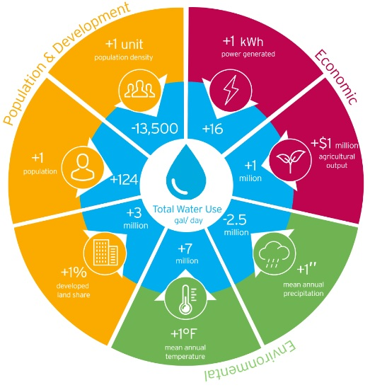

*Source: Brookings analysis of data from USGS (water use), Moody's Analytics (GDP), U.S. Energy Information Administration (EIA) (net electricity generation), Census (population and density), and Vanderbilt Institute for Energy and Environment (land cover, temperature, and precipitation)*

In line with previous studies, certain types of industrial activity—namely, energy and agricultural production—have a positive effect on total water use. In particular, an increase of 1 kilowatt-hour (kWh) of electricity generated each day is associated with more than 16 additional gallons of total water use per day, while an additional $1 million in agricultural output is associated with nearly 1 million gallons of total water use each day.[118] Higher temperatures and lower amounts of precipitation are also linked to greater total water use; 1 extra degree in mean annual temperature is associated with more than 7 million additional gallons of total water use each day, while having 1 inch less in annual precipitation is associated with almost 2.5 million additional gallons of total water use each day. Warmer, semi-arid places in California’s Central Valley, such as Fresno, stand out in this way, as shown in Table 2.

**Table 2. Top 10 counties for total water use each day,**

**with selected economic and environmental variables, 2010**



*Note: Other counties with higher water use totals are excluded because of a lack of data for some variables.*

*Source: Brookings analysis of data from USGS (water use), Moody's Analytics (GDP), EIA (net electricity generation), Census (population and density), and Vanderbilt Institute for Energy and Environment (land cover, temperature, and precipitation)*

Interestingly, the distribution of a county’s population and the level of its physical development are among the other major variables estimated to have a significant effect on total water use. Overall, each additional person is associated with 124 more gallons of total water use per day—in line with total per capita estimates explored earlier in this report. The more physical development covering a county’s land area—including asphalt, concrete, and buildings—also tends to lead to more water use; specifically, a 1 percent increase in the share of developed land is associated with more than 3 million additional gallons of total water use each day.[119] Crucially, however, counties with a greater concentration of population and more compact development tend to use *less* water. For example, an increase in a county’s population density by one unit is associated with 13,500 fewer gallons of total water use each day. As a result, a smarter, compact mix of land uses is likely to require less water—and potentially result in greater efficiencies—than more sprawling development patterns.

For residential water use, the second model finds that several housing and demographic variables are estimated to have a significant effect on county-level withdrawals. Population is the single most important variable; each additional person is associated with 99 more gallons of residential water use per day—comparable to but slightly higher than the 88 gallons per capita shown earlier in this report. Moreover, if the number of people living in each household increases, more water is also often needed; an increase of one person in the average household size across a county is associated with 3 million or more gallons of residential water use each day. Similar to the first model looking at total water use, higher temperatures and lower levels of precipitation are also associated with increased residential water use. Table 3 lists the counties with the highest levels of residential water use, many of which tend to share these characteristics, such as San Diego and Riverside, Calif.

**Table 3. Top 10 counties for residential water use each day, with selected housing, demographic, and environmental variables, 2010**



*Note: Other counties with higher water use totals are excluded because of a lack of data for some variables.*

*Source: Brookings analysis of data from USGS (water use), Census (population, density, and housing), and Vanderbilt Institute for Energy and Environment (temperature and precipitation)*

The specific type of housing can also have a significant effect on residential water use. For instance, a 1 percent increase in the share of multiunit housing is associated with 185,000 *fewer* gallons of residential water use each day. In other words, the presence of apartments and other structures beyond detached or attached single-unit housing tends to result in lower levels of water use, paralleling the first model’s finding on higher population density. However, as the values of all housing units increase, the opposite occurs; a $1 increase in the median value of a county’s housing units is associated with 35 additional gallons of residential water use. Of course, several other housing characteristics can be playing a role as well—including the age of these units, the presence of more efficient appliances, and variations in outdoor space—and exploring these details in greater depth is an area ripe for additional analysis.

Indeed, the same proves true for examining particular demographic variables. The second model explores how age, education, and race are related to residential water use, but the results are less clear. While controlling for other factors, counties with an older, more educated population tend to have lower levels of residential water use, as do counties with a higher minority share of population. At the same time, gauging the effects of household incomes and water prices remains complicated.[120] As researchers continue to refine available data sources and develop more consistent methods to compare water use at a subnational level, it will be useful to reassess these and other variables of interest to investigate potential implications for household equity.

**Implications and recommendations**

Nationally, water use patterns underscore the variety of industries, households, and infrastructure assets that are foundational to U.S. economic growth, environmental sustainability, and other long-term goals. Yet, supporting these economic actors and strengthening these assets remains a challenge, especially when many federal policymakers rely on strategies that tend to paint in broad strokes and do not offer much clarity on where (or how) any investments should take place. Meanwhile, state and local leaders may focus more on projects specific to individual water systems, failing to address broader regional needs and economic challenges.

However, by taking a closer look at metro and nonmetro water use patterns, one enormous challenge becomes clear: the dual stress that leaders in many metro areas face achieving greater economic efficiencies while promoting economic equity. Declining levels of water use hold promise for a more sustainable future, but utilities and other users must still grapple with aging, inefficient infrastructure, which requires an influx of new investment and results in a growing cost burden.

As a result, leaders in many places must address pressing infrastructure concerns at a time when less water—and unpredictable water demand—is leading to more financial and economic risk. Steps toward greater water efficiency are crucially important from an environmental standpoint, but these leaders must closely monitor and manage these shifts with a broader set of economic concerns in mind.

Defining the specific location and scale of this challenge can easily elude policymakers, but several trends emerge from this report that highlight the importance of viewing water management from a more regional perspective.

At a basic level, metro areas matter when it comes to national water use. They make up nearly two-thirds of all water withdrawals each day. Furthermore, as the U.S. sees a decline in water use, metro areas play an even more significant role; of the 42 billion-gallon reduction in water use each day since 1985, metro areas have been responsible for 39 billion gallons, or more than 90 percent of the national decline. The 100 largest metro areas are especially important, accounting for 71 percent of the decline by themselves. In short, these populated, urbanized markets have figured prominently in recent developments concerning U.S. water use and will likely continue to do so in years to come. Managing the country’s future water infrastructure needs is not an exclusive urban or rural phenomenon, but it demands attention from the biggest users, many of which concentrate in metro areas.

Specific categories of water use can also vary across different metro and nonmetro areas, pointing to the need for additional flexibility in how larger federal and state policies approach infrastructure challenges. While water represents a major input for many industries and businesses, particularly those focused on thermoelectric power and irrigation, water use can vary widely across different localities. Public supply water use—which includes most of the country’s residential use—is concentrated in more populated metro areas, where it is one of the only categories nationally that *increased* in withdrawals from 1985 to 2010. Targeting water infrastructure plans based on these category-specific patterns can help leaders in metros, nonmetros, and the country as a whole respond more precisely and consistently to ongoing needs in support of additional efficiencies.

Water use is on the decline nationally, but there are clear gaps in efficiency in different parts of the country.[121] This is especially important to consider as metro economies and populations continue to grow, placing enormous pressure on specific utilities and other users to conserve scarce water resources. As industrial patterns change and new technologies emerge, metro areas are leading the way, particularly when it comes to total water use per capita, in which they tend to be much more efficient (840 gallons per capita each day) than nonmetro areas (2,810 gallons). Striving for additional efficiency gains in thermoelectric power and irrigation is critical in this way.

On the other hand, for metro areas experiencing continued increases in public supply water use—or facing unpredictable demands in general—gains in residential water efficiency should remain a top priority. The bigger challenge in doing so, though, concerns the ability of utilities to implement new technologies and other infrastructure improvements affordably when they may be generating less revenue from their overall volumetric rates and are passing along costs to the most vulnerable households through increased rates. While industries and individuals are striving to use less water and promoting greater sustainability, these actions can also hurt the ability of utilities to invest in infrastructure. Therefore, new ways of planning and paying for future improvements are key.

Finally, several economic, environmental, and demographic factors influence variations in metro and nonmetro water use, revealing some of the major levers available to policymakers and planners to better manage water. Industrial activities, including energy and agriculture, remain two of the primary drivers behind total water use nationally and should warrant continued attention from metro and nonmetro areas alike; technological upgrades and other alternative water management practices are key in this way.[122] In addition, the inextricable link among temperatures, precipitation, and water use will require more resilient solutions as the climate fluctuates.[123]

Perhaps most crucially, the scale and type of development taking place in communities can have a profound effect on water use. Places with higher population densities, shares of multiunit housing, and compact development patterns tend to have lower levels of total and residential water use. Exploring these results in greater depth, alongside other relevant indicators such as water prices, represent clear next steps for places looking to encourage more efficient and equitable outcomes.

These trends reaffirm that there are no one-size-fits-all solutions to the country’s water infrastructure challenges. Defining water use more clearly in terms of metro area concerns provides a more consistent barometer to compare different places and weigh different needs. Ultimately, coordinated efforts at local, state, and federal levels are essential to respond to such needs.

**BOX D: Understanding water infrastructure governance**

When thinking about potential strategies to address the country’s water infrastructure challenges, it is crucial to consider the vast array of federal, state, and local players involved. Administrative and programmatic functions, such as monitoring water quality, managing assets, or providing technical guidance, are often split across multiple layers of government, making it difficult to craft integrated and comprehensive infrastructure strategies.[124]

The federal government embodies these concerns. With responsibilities divided among various agencies and several other executive and congressional staffs, the federal role is expansive in terms of infrastructure oversight, regulatory action, and policy direction. EPA is the most notable agency in this respect, responsible for enforcing provisions of the Clean Water Act and Safe Drinking Water Act—the two major laws protecting American water resources and public water supplies—and for overseeing numerous environmental programs and technical assistance efforts.[125] The departments of Energy (DOE), Agriculture (USDA), and Interior (DOI) are among the other federal agencies that manage standards and programs in support of water efficiency, sustainability, and investment. Likewise, Congress maintains control over the appropriations process for different programs and crafts supporting legislation, such as the Water Resources Development Act, via several committees.[126] Finally, the White House, including such bodies as the Council on Environmental Quality (CEQ), exerts influence over policies and plans.[127]

Despite the federal government’s sizable role overseeing water regulations, operating related programs, and setting certain strategic priorities, its importance for infrastructure investment is quite limited by comparison. Unlike states and localities that are bearing most of the financial burden, the federal government accounts for just 4 percent of total public spending on water infrastructure (or about $4.3 billion out of $109 billion), a share that has held fairly steady in recent years.[128] EPA is the primary agency responsible for channeling federal spending on water by capitalizing state-led water loan programs, or state revolving funds (SRFs), for clean water and drinking water projects, which amount to about $2.5 billion annually.[129] While the SRFs have helped finance thousands of water projects nationally since their inception decades ago, the demand for additional support remains high.[130] The Water Infrastructure Finance and Innovation Act (WIFIA) pilot program aims to complement the SRF programs and help support larger projects, although concerns linger on eligibility requirements and implementation.[131] Other agencies, including USDA, help administer grant and loan programs directly to communities, many of which may struggle to receive assistance from the SRFs.[132]

**Figure 13. Real spending on water infrastructure by federal, state, and local governments,**

**1956 to 2014**

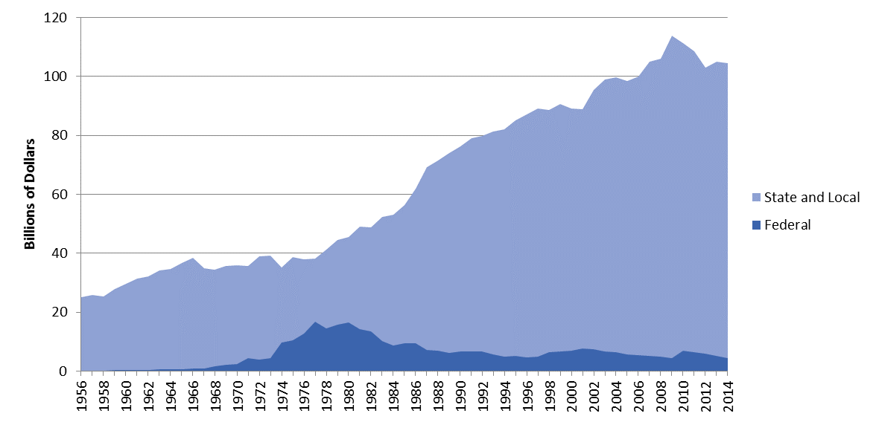

*Note: Water infrastructure spending is for water supply and wastewater treatment only, excluding water resources.*

*Source: Brookings analysis of Congressional Budget Office data*

State governments also execute water investment and regulatory oversight. Since physical, financial, and legal issues can vary widely across states, the specific types of agencies and institutions can operate differently, especially when managing water rights and allocating water among users.[133] Moreover, since many watersheds do not conform to political boundaries, several states use cross-state partnerships to manage their shared water resources.[134] In general, though, states depend on overarching environmental departments that coordinate water plans and other programmatic activities within their borders, which frequently act as a bridge between federal agencies and localities in managing water quality, quantity, and compliance.[135] In addition to monitoring and enforcing water regulations—a challenging task in itself—these state-level bodies also help oversee SRF programs to provide loans and other subsidies for local infrastructure improvements. Finally, states’ public utility commissions oversee local water service decisions, including adjustments to service areas and rates.[136]

Beyond federal and state support, governing water locally—in a city or county, or across an entire metropolitan area—requires perhaps the most vigilant action each day. Unlike the electric utility industry, which operates on an interconnected grid, water systems are disjointed and subject to localized control and ownership.[137] With dozens of separate utilities often situated in a given locality, a lack of coordination can lead to operating inefficiencies and limited economies of scale to provide reliable, affordable service to consumers.[138] Likewise, the dizzying number of projects to carry out puts pressure on utilities to develop comprehensive plans, create detailed metrics, and secure financial resources—despite high levels of debt and other political challenges in many cases.[139] Doing so, of course, also ideally hinges on involvement from all types of local stakeholders, including mayoral leadership, economic development agencies, and private partners such as developers, farmers, and other businesses, which may be resistant to change. In short, the local governance challenge is not easy.

As a whole, these federal, state, and local governance structures result in a complex, ever-shifting puzzle of responsibilities. This should not be too surprising given the variety of water infrastructure needs across the country, but it creates several barriers to driving more efficient and equitable decisions. Leaders at all levels of government need to work actively with one another to take greater shared ownership of the challenges at hand and devise crosscutting solutions.

***Local strategies: Implementing new plans, financial tools, and technological Innovations***

Leaders in metro and nonmetro areas—including utilities and other large water users—are well-positioned to tackle their water infrastructure challenges head-on. Since they are often directly involved in overseeing water use, they can more closely track resource limitations, operational demands, and other hurdles to water management. Furthermore, they can engage in peer-to-peer learning and share best practices. The bigger challenge, though, is uniting action among different local actors and creating more holistic management strategies, which not only respond to short-term maintenance needs, but also emphasize long-term fixes and economic priorities.[140]

**As a starting point,** **developing more comprehensive water plans can encourage greater collaboration and strategic action**. Integrated water resources management, which involves coordinated water planning in light of different land use, economic, and environmental considerations, is helping cities and entire regions bring groups together in support of more efficient and equitable outcomes.[141] Integrated water planning efforts, of course, remain difficult to execute in reality among several different agencies and are not a catch-all solution for the water infrastructure issues that metro areas face nationally.[142] The consideration of water supply and distribution needs alongside other expansive wastewater and stormwater concerns is not always clear-cut and may not uniformly translate into the same economic vision (or outcomes) desired in different markets.[143]

However, these efforts, including “One Water” planning, are helping utilities, industries, and other local leaders work more closely together to define their water priorities—from diversifying water supplies to forging new partnerships to supporting more affordable water access.[144] A One Water approach also encourages local leaders to focus on a broader mix of green and gray infrastructure projects, including a variety of centralized and decentralized facilities that are geared toward regulatory compliance and more sustainable water management.[145] The One Water LA plan, for instance, is helping Los Angeles and prompting neighboring jurisdictions to consider alternative ways to manage scarce water supplies in support of regional economic growth and affordability.[146]

When developing or enhancing their water infrastructure plans, metro leaders should ideally view them in terms of the particular users served, including the larger built environment. As this report has shown, households and businesses use less water when located in markets with smarter, denser development patterns. Previous studies have pointed to the same trends, including the need to accommodate future population and economic growth in ways that minimize water use, distribution costs, and ongoing capital and operational expenses.[147] In addition to encouraging a mix of land uses in close proximity to essential services—such as water—some localities are implementing novel planning tools in support of more efficient and sustainable use. For example, Santa Fe, N.M., is among 13 communities nationally that have created water neutrality ordinances, which require developers to adopt conservation measures based on the amount of water demanded by a particular project.[148] San Antonio is among several areas that have also viewed future water needs in terms of development and population changes.[149]

If designed well, these planning measures can support more a resilient built environment. Water availability and reliability are critical issues that remain at the top of many utilities’ priority lists, and are likely to become even more significant as temperatures and precipitation levels fluctuate rapidly in years to come.[150] Many areas, from New York to New Orleans, are already addressing these issues by crafting new adaptation strategies and exploring ways to safeguard sensitive water resources.[151] Places such as Boston, moreover, are striving toward efficient energy upgrades via building codes, which is decreasing water use and increasing transparency on new metrics.[152] A variety of civic and philanthropic partners are also proving instrumental in these efforts, helping coordinate water management plans across different urban watersheds and localities.[153] When it comes to reducing levels of urban irrigation, even golf courses and their managers have a role to play.[154]

Planning for future water needs at a larger regional scale, though, does not simply end with improved efficiency and sustainability; ensuring that all users have equitable and affordable access is key. And once again, compact development is a major way to support more cost-effective service: the closer households are to needed public water supplies—and the smaller the lot size—the lower the water bills tend to be than for larger, more dispersed households.[155] Planners need to carefully weigh the type of development and infrastructure improvements taking place across an entire region. Tucson, for instance, is implementing a targeted low-income rainwater harvesting program—designed to support the creation of rainwater collection systems in higher poverty areas—that provides more sustainable, affordable water to the most vulnerable household users.[156] As residential water bills surge in many markets and outpace inflation, utilities and other local leaders need to consider all tools at their disposal, which should relate directly to how they plan their communities.

**In much the same way, beyond planning,** **metro leaders must also confront a complicated and long-standing barrier to efficient and equitable water use: how to pay for infrastructure maintenance and upgrades**. Utilities, in particular, are facing a crunch to provide reliable, affordable water, often for a growing customer base as this report has illustrated. With almost a 75 percent decline in federal spending on water since the late 1970s, this also means they have to cobble together most of the financial resources by themselves—and from their customers.[157] Ultimately, utilities and the users they serve must bear a heavier cost burden. Yet, several new tools and best practices that are emerging nationally offer a clearer path forward.

The creation of more robust water asset management plans and the development of new revenue streams are two of the major types of efforts underway, which both hold promise for improved regional water management and addressing the cost of service. First, with a more thorough accounting of their assets, utilities can more accurately determine the entire life cycle of different infrastructure facilities and set priorities for certain improvements—steps that can help respond to increased demand for services and promote more sustainable water use.[158] Second, by exploring new ways to generate revenue and ultimately creating a more resilient business model, utilities are seeking a more flexible way to respond to changing water demands with greater certainty.[159] Utilities in North Carolina, Georgia, and Texas have been engaged in these efforts.[160] Localities are also experimenting with different financial tools and arrangements to support long-term upgrades—from DC Water’s green century bonds to San Francisco’s certified water climate bonds, the first of their kind.[161] Providing incentives for water reuse and other novel water management practices should also be front and center in these discussions.

The need for new local funding and financing tools is also closely intertwined with issues concerning water access and affordability. Users in metro and nonmetro areas are reducing their water withdrawals—while these places are seeing gains in population and economic output. In short, this means that many utilities are facing the dual stress of generating less revenue from volumetric rates—because less water is being used—but they are having to reach more customers, who can often have unpredictable demands. This has caused water rates to spike in many places nationally and led to serious questions over the “price” of water and how much users can affordably pay.[162]

Fortunately, new financial models are emerging to address these efficiency and equity concerns together. While utilities tend to rely on volumetric charges to generate revenue, they are also turning more toward fixed fees—such as connection charges—to provide revenue stability regardless of the levels of water used. For example, Austin Water is among the utilities experimenting with new types of consumption-based fixed rates that aim to reduce peak water demand, avoid revenue volatility, and ultimately limit the need for costly repairs.[163] In addition, several localities are creating (or strengthening) customer assistance programs, which offer useful models to consider in alleviating this cost burden. Philadelphia, for instance, recently unveiled a tiered assistance program that links water bills more closely to income considerations,[164] while residents in Detroit and surrounding jurisdictions are seeing more relief through regionwide assistance programs.[165] Still, recent surveys indicate that up to three-quarters of utilities nationally lack any type of customer pricing assistance program, which leaves many households struggling to pay for water.[166]

**In addition to exploring new plans and financial tools, metro leaders should emphasize technological innovation to drive additional efficiencies**. Reducing water withdrawals for thermoelectric power and irrigation are especially important in this way, but utilities and other local leaders should seek to incorporate more efficient technologies across all categories of water use. The key is stimulating the widespread investment in and use of these new technologies. By doing so, regions may spend more money today, but they can save more money tomorrow through reduced infrastructure costs (and lower customer bills). Although many efforts are already underway in different industries and households across the country, the relative lag in water technology investment and implementation signals that there is still a need for improvements.

When it comes to energy, leaders in metro and nonmetro areas should build from ongoing successes. Upgrades in energy generation technology, including closed-loop cooling systems, have helped power plants of all types reduce their water demands and resulted in a cleaner, more sustainable environment.[167] Planners should become more familiar with the water needs of local energy facilities and more consistently track how these needs vary depending on the availability of local water supplies; in some regions, for instance, water-intensive coal and biofuel plants may be sustainable in the short run, but shifts toward less-intensive solar and wind power facilities should be seriously considered.[168] Several municipal and investor-owned utilities are trying to further encourage improvements, not only through better tracking but also through expanded energy efficiency financing programs. The Northwest Energy Efficiency Alliance is one such cross-regional effort aimed at building capacity in this direction, uniting action among several small utilities.[169]

Likewise, in the agricultural sector, there is the potential for more efficient irrigation that integrates improved on-farm water management practices with advanced application systems, especially since more than half of irrigated cropland acreage nationwide is still supported by traditional inefficient methods.[170] However, several regions, including many of the most water-intensive areas in California’s Central Valley, are deploying new technologies, data platforms, and management strategies to address their water scarcity.[171] Providing sales tax exemptions and rebates for more efficient equipment, supporting certain property tax benefits, and considering other subsidies are among the steps that policymakers are taking to encourage greater local innovation.[172] Continued collaboration and joint efforts between utilities and farmers will be key to replicating these solutions.

Industries, utilities, and households should also remain a big part of water innovation at a local level. By incorporating new technologies, altering processes, and better quantifying their water footprint (that is, how much water is used to make particular products), small and large manufacturers alike should continue exploring ways to achieve efficiency gains. Food and beverage companies, for instance, have tried to limit and reuse the amount of water they require in their operations, with some taking water neutrality pledges to fully return water into the environment.[173] Milwaukee, for instance, has become a hub for water industry research with more than 200 water technology businesses in the region.[174] The economic importance of achieving greater efficiencies should not be underestimated; in neighboring Michigan, one in five jobs are water-dependent, inextricably linked to the Great Lakes through manufacturing and other sectors.[175]

The amount of energy and waste that water utilities themselves must also limit is extraordinary, which several regions are already addressing through better leak detection, water reuse, and other new treatment processes. For example, the Southern Nevada Water Authority is among several systems that have implemented direct and indirect water reuse processes;[176] DC Water’s Blue Plains Advanced Wastewater Treatment Plant has reused biosolids and recycled other nutrients to reduce electricity consumption;[177] and the San Diego County Water Authority has pioneered various “pure water” improvements and explored desalination as way to more efficiently use scarce water resources.[178] Lastly, households should also be active in these efforts; local incentives to install low-flow toilets, showers, and washers can make a difference, as can other outdoor water use improvements.[179] Utilities are helping household users pursue these efficiencies via rebate programs, bill credits, and other incentives.

***State and federal strategies: Building financial capacity, boosting collaboration, and providing policy direction on innovation***

The range of local issues and actors involved in managing water infrastructure demands targeted solutions for effective implementation. However, metro and nonmetro areas must still contend with a highly fragmented set of water challenges and cannot address these issues alone; state and federal leaders should help utilities, industries, and households across the country achieve greater financial and technical capacity to unlock new solutions. At the same time, establishing a clearer policy framework to guide these efforts is essential, including steps toward greater technological innovation. State and federal leaders are admittedly in a challenging position themselves—having to balance multiple other regulatory and budgetary responsibilities—but they should seek iterative, actionable ways to accelerate water infrastructure improvements in the months and years to come.

**First, as with all types of infrastructure nationally, these state and federal efforts must address sticky questions on how to pay for future improvements**. Although the water funding gap is significant and more overall investment would help utilities, in particular, operate with greater certainty, this does not mean that state and federal leaders should swing for the fences.[180] Instead, state and federal leaders should pursue a combination of short-term and long-term strategies, based on a reasonable expectation to get certain projects done.[181] At a state level, for instance, ballot measures can help introduce new revenue streams and build political support for targeted water investment.[182] Supporting low-cost loans and other grant opportunities has gained traction in states such as New York and Pennsylvania, where governors have emphasized the need to invest in a broad range of water projects to support regional sustainability and economic growth.[183]

At the federal level, an infusion of new funding for SRFs would provide a stronger channel for additional state and local investment,[184] but offering greater financial flexibility via a strengthened Water Infrastructure Finance and Innovation Act (WIFIA) program would also offer a clearer outlet to pursue a variety of different projects.[185] EPA and USDA are among the multiple federal agencies that should be involved in supporting additional financial and technical capacity among different localities, building on past efforts to improve asset management among smaller utilities.[186] Maintaining the tax-exempt status of municipal bonds,[187] encouraging the wider use of private activity bonds, and exploring the potential for PPPs should also be considered. However, as the Trump administration and Congress increasingly emphasize the role of private and institutional investors in infrastructure, federal leaders will need to weigh these relatively new collaborations carefully; integrating water into investment portfolios is not a straightforward process, which should ideally examine broader public benefits, including sustainability.[188]

Finally, federal and state leaders must be sure to connect these broader financial considerations with more specific affordability guidelines. As this report has shown, metro and nonmetro areas must not only address their water management needs and related infrastructure gaps, but also weigh them in light of particular needs among users, including households that may struggle to pay their water bills. EPA’s affordability guidelines—which focus on water rates as a share of median household income—are often lacking in this respect and should capture a greater variety of income groups and regional concerns. While federal policymakers are having more conversations on this matter, states are starting to take action; California is creating the nation’s first statewide water affordability program, intended to help low-income ratepayers achieve greater cost savings and equitable access.[189] States should also consider revising potential legal barriers to forming local customer assistance programs, allowing utilities to more easily navigate what can be a byzantine set of regulations to design and fund such programs.[190]

**Alongside discussions on water finance, state and federal leaders should also develop more comprehensive plans and collaborations in support of regional infrastructure upgrades.** Many states have long adopted such an approach—including the development of multistate collaborations focused on water management across political boundaries—and should continue to foster stronger partnerships. States along the Colorado and Delaware rivers, for instance, have engaged in extensive river basin management agreements, which at times have been contentious but are crucial in addressing water supply issues across multiple regions.[191]

Federally, on the other hand, cross-agency collaborations and planning efforts remain a work in progress and must continue to pick up momentum. Nascent initiatives, such as the Urban Waters Federal Partnership, have helped increase coordination among different agencies to accelerate infrastructure improvements in economically distressed regions nationwide and offer a useful model to consider.[192] Likewise, EPA’s Water Infrastructure and Resiliency Finance Center[193]and WaterCARE (Community Assistance for Resiliency and Excellence) initiative[194] have helped build greater technical capacity for regions interested in pursuing innovative financial tools and defining clearer economic development strategies. Congressional proposals focused on integrated water planning also hold promise in boosting regional capacity and should be monitored closely.[195]

**While considering these new approaches, state and federal leaders must also recognize that improving regional water management involves a constantly moving target; as population and climate concerns continue to intensify, water needs will fluctuate widely and require an eye toward greater technological innovation**. In light of federal uncertainty in this space following the Paris Climate Agreement withdrawal by the Trump administration, states are in an especially strategic position to encourage innovations across metro and nonmetro areas. Following the precedent set in the clean energy sector, for instance, states should adjust inconsistent regulations, enact new performance standards, and consider other public benefit charges—via state-led innovation offices—to support more widespread technological innovation and adoption.[196] Western states with the most pressing water scarcity issues, such as California, Arizona, and Texas, could serve as a test bed for these efforts, while considering other market-driven management strategies.[197]

With that said, the federal role should not be easily dismissed. For example, federal agencies such as DOE and EPA should coordinate on innovation-led programs in support of greater water efficiency, including the continued development of best management practices[198] and efforts within the Innovations for Existing Plants Program.[199] Continuing to support EPA’s WaterSense program is also enormously important to expand the market for water-efficient products and appliances.[200] Having a more reliable baseline of water use data and other metrics will be crucial in any future federal efforts and should remain a top priority as well. USGS, the National Oceanic and Atmospheric Administration, and several other agencies have started to collaborate more on this front, especially for projects focused on resilience, but they should further expand these platforms.[201]

**Conclusion**

While water infrastructure needs are gaining greater attention nationally, this report demonstrates the tremendous regional variety in these challenges throughout the country. By exploring how water use varies across metro and nonmetro areas, it provides a more comprehensive and consistent way to gauge water demands and infrastructure considerations from place to place, which helps fill a long-standing analytical gap among researchers and practitioners. Taking such an approach is crucial to supporting more environmentally sustainable outcomes and driving more economically efficient and equitable solutions.

With nearly 355 billion gallons of water used each day, the U.S. depends on a wide assortment of aging and brittle water infrastructure facilities. Millions of businesses, households, and other users rely on a steady supply of water to carry out their economic activities, particularly those focused on energy production and irrigation. Yet, for the most part, water use is on the decline, falling by 42 billion gallons each day, or 11 percent, since 1985. Despite continued gains in population and economic output, the U.S. is generally becoming more efficient in its water use, minus certain pressures facing public supply use. As a result, many water utilities are facing the dual stress of receiving less overall revenue while having to provide reliable and equitable service to a growing customer base; in turn, water bills are rising to unaffordable levels to help cover needed infrastructure improvements.

In other words, as many places use less water and face more unpredictable water demands, utilities and other regional leaders are confronting greater financial and economic risks when addressing their infrastructure needs.

These national trends play out in different ways at a metropolitan scale and emphasize the need to develop more targeted infrastructure strategies. Above all, these strategies need to move beyond anecdotal urban and rural comparisons, and look instead toward the sizable role played by metro areas and nonmetro areas alike. In particular, metro areas such as New York and Chicago are the major centers of the country’s water use. Collectively, users in metro areas withdraw more than 221 billion gallons of water each day, or 63 percent of the U.S. total. Metro areas are also the primary sites for many of the utility concerns just described; they are responsible for 83 percent of public supply use and have had the greatest reductions in total water use since 1985 (39 billion gallons a day). While metro gains in efficiency are helping the U.S. achieve greater economic productivity and environmental sustainability, utilities and other water users still have to cope with enormous infrastructure costs and affordability concerns. A range of economic, environmental, and demographic factors help explain how these variations are playing out at a subnational level, where climate concerns, sprawling development patterns, and certain household characteristics are important to bear in mind.

Ultimately, with a better understanding of their water use patterns, leaders in metro areas and nonmetro areas can more clearly weigh their infrastructure demands and begin to plot out more specific next steps on how to address them. Local leaders can consult this new body of information—alongside other metrics—to implement new plans, financial tools, and technological innovations in support of more efficient and equitable water use. At the same time, federal and state leaders can help bolster the financial capacity of metro areas as they undertake these efforts, while encouraging greater collaboration and providing a clearer policy direction for innovation. Designing and deploying these strategies will take time and not necessarily come easily, but they offer a clearer direction for the U.S. as whole to address its substantial and fragmented water infrastructure challenges.

**Endnotes**

1. Jim Gebhardt, “The Time to Invest in America’s Water Infrastructure Is Now,” *The EPA Blog,* July 12, 2016, <https://blog.epa.gov/blog/2016/07/the-time-to-invest-in-americas-water-infrastructure-is-now/> (accessed June 2017).
2. Alexander Quinn et al., *National Economic and Labor Impacts of the Water Utility Sector* (Water Research Foundation, 2014).
3. American Water Works Association (AWWA), *Buried No Longer: Confronting America’s Water Infrastructure Challenge,* 2011, <http://www.awwa.org/portals/0/files/legreg/documents/buriednolonger.pdf> (accessed June 2017).
4. Joseph Kane, *Investing in Water: Comparing Utility Finances and Economic Concerns across U.S. Cities* (Washington, DC: Brookings Institution, 2016).
5. Value of Water Campaign, *The Economic Benefits of Investing in Water Infrastructure,* 2017.
6. David Monsma, Regan Nelson, and Ray Bolger, *Sustainable Water Systems: Step One – Redefining the Nation’s*

   *Infrastructure Challenge* (Washington, DC: The Aspen Institute, 2009).
7. For more information on defining green infrastructure, see: U.S. Environmental Protection Agency, “What Is Green Infrastructure?” <https://www.epa.gov/green-infrastructure/what-green-infrastructure> (accessed June 2017).
8. Molly A. Maupin, Joan F. Kenny, Susan S. Hutson, John K. Lovelace, Nancy L. Barber, and Kristin S. Linsey, *Estimated Use of Water in the United States in 2010* (Washington, DC: U.S. Geological Survey, 2014).
9. For more background on these uses, see: Benjamin H. Harris, Brad Hershbein, and Melissa S. Kearney, “Tidal Wave or Drop in the Bucket? Differences in Water Use Across the United States” (Washington, DC: Brookings Institution, 2014).
10. Note that this report does not concentrate on freshwater or saline water use. For the most part, the country depends on freshwater sources.
11. Note that this report does not focus on “applied” water use, which relates more directly to consumptive-use estimates for agriculture. The USDA examines these types of uses in greater depth, revealing that agriculture is responsible for up to 80 percent of the country’s consumptive water use: <https://www.ers.usda.gov/topics/farm-practices-management/irrigation-water-use.aspx#definitions> (accessed July 2017).
12. In other words, these concerns tend to relate more to drinking water infrastructure issues, as opposed to clean water issues. For more information on these system classifications and needs, see: U.S. Environmental Protection Agency, *Drinking Water Infrastructure Needs Survey and Assessment,* 2013.
13. Charles Fishman, “13 Things You Probably Don’t Know About the U.S. Water System (But Should),” *National Geographic,* August 12, 2014, <http://voices.nationalgeographic.com/2014/08/12/13-things-you-probably-dont-know-about-the-u-s-water-system-but-should/> (accessed June 2017).
14. This is particularly true within regions when addressing climate concerns and other related issues. For example, see: Water Environment Research Foundation (WERF), “Water/Wastewater Utilities and Extreme Climate and Weather Events,” 2014, <http://www.waterrf.org/PublicReportLibrary/4416.pdf> (accessed June 2017).
15. Note that in addition to community water systems, “nontransient noncommunity water systems” (including schools, hospitals, and certain types of office buildings) and “transient noncommunity water systems” (including gas stations and campgrounds) also play an enormous role in the country’s total water infrastructure network. These additional systems bring the total of public water systems across the country to 151,000.
16. Patrick Sabol, Joseph Kane, and Robert Puentes, “Water Systems Everywhere, a Lot of Pipes to Fix” (Washington, DC: Brookings Institution, 2015).
17. Andrea Kopaskie, “Public vs Private: A National Overview of Water Systems,” *Environmental Finance Blog*, University of North Carolina Environmental Finance Center, October 19, 2016, <http://efc.web.unc.edu/2016/10/19/public-vs-private-a-national-overview-of-water-systems/> (accessed June 2017).
18. Ibid.
19. National Association of Water Companies, “Private Water Service Providers Quick Facts,” <http://www.nawc.org/uploads/documents-and-publications/documents/document_ecf5b3ac-c222-4b6c-b99f-a0128ae1e9aa.pdf> (accessed June 2017).
20. Patrick Sabol and Robert Puentes, *Private Capital, Public Good: Drivers of Successful Infrastructure Public-Private Partnerships* (Washington, DC: Brookings Institution, 2014).
21. Maupin et al., 2014.
22. Thomas C. Winter, Judson W. Harvey, O. Lehn Franke, and William M. Alley, *Ground Water and Surface Water: A Single Resource* (Denver: U.S. Geological Survey, 1998).
23. For example, California and other regions across the Intermountain West must confront these challenges. For more background, see: Water Education Foundation, “The 2014 Sustainable Groundwater Management Act: Approach and Options for New Governance,” 2015, <http://groundwater.ca.gov/docs/WEFSGMA-Approaches_and_Options_for_New_Governance_00282995xA1C15.pdf> (accessed June 2017).
24. U.S. Environmental Protection Agency, 2013.
25. National Association of Clean Water Agencies (NACWA) and Association of Metropolitan Water Agencies (AMWA), “Confronting Climate Change: An Early Analysis of Water and Wastewater Adaptation Costs,” 2009, <https://www.amwa.net/galleries/climate-change/ConfrontingClimateChangeOct09.pdf> (accessed June 2017).
26. American Water Works Association, 2011.
27. Center for Neighborhood Technology, *The Case for Fixing the Leaks: Protecting People and Saving Water While Supporting Economic Growth in the Great Lakes Region,* 2013.
28. Alison Young and Mark Nichols, “Beyond Flint: Excessive Lead Levels Found in Almost 2,000 Water Systems across All 50 States,” *USA Today*, March 11, 2016, <https://www.usatoday.com/story/news/2016/03/11/nearly-2000-water-systems-fail-lead-tests/81220466/> (accessed June 2017).
29. Gebhardt, 2016.
30. For additional context on how states and localities are dealing with federal uncertainties, especially regarding SRFs, see: Mary Tiemann, *Drinking Water State Revolving Fund (DWSRF): Program Overview and Issues* (Washington, DC: Congressional Research Service, 2017).
31. Claudia Copeland and Mary Tiemann, *Water Infrastructure Needs and Investment: Review and Analysis of Key Issues* (Washington, DC: Congressional Research Service, 2010).
32. This is especially true after the Flint water crisis. For more, see: Joseph Kane and Robert Puentes, “Flint’s Water Crisis Highlights Need for Infrastructure Investment and Innovation” (Washington, DC: Brookings Institution, 2016).
33. Ernst & Young and Simul Consulting, “The US Water Sector on the Verge of Transformation,” 2013, <http://www.ey.com/Publication/vwLUAssets/Cleantech_Water_Whitepaper/$FILE/Cleantech-Water-Whitepaper.pdf> (accessed June 2017).
34. The Johnson Foundation at Wingspread and the Alliance for Water Efficiency, *Declining Water Sales*

    *and Utility Revenues: A Framework for Understanding and Adapting,* 2012, <http://www.allianceforwaterefficiency.org/uploadedFiles/Resource_Center/Library/rates/Summit-Summary-and-Declining-Water-Sales-and-Utility-Revenues-2012-12-16.pdf> (accessed June 2017).
35. It is worthwhile to note, however, that new research reveals that increased conservation and lower levels of water use can also result in reduced rates in some cases. For more background, see: Brett Walton, “Saving Water Lowered Rates in Two Arizona Cities,” *Circle of Blue,* July 14, 2017, <http://www.circleofblue.org/2017/water-management/saving-water-lowered-rates-two-arizona-cities/> (accessed July 2017).
36. Joseph Kane and Robert Puentes, “Measuring Water’s Sizable Impact on the Economy and Job Market” (Washington, DC: Brookings Institution, 2014).
37. Elizabeth A. Mack and Sarah Wrase, “A Burgeoning Crisis? A Nationwide Assessment of the Geography of Water Affordability in the United States,” *PLOS ONE* 12, no. 1 (2017).
38. Manuel P. Teodoro, “Tailored Rates,” *Journal (American Water Works Association)* 94, no. 10 (2002): 54–64.
39. AWWA, 2011.
40. Janice A. Beecher, “The Conservation Conundrum: How Declining Demand Affects Water Utilities,” *Journal (American Water Works Association)* 102, no. 2 (2010): 78–80.
41. Joseph Kane and Lynn E. Broaddus, “Striking a Better Balance between Water Investment and Affordability” (Washington, DC: Brookings Institution, 2016).
42. Hug March Corbella and David Saurí Pujol, “What Lies behind Domestic Water Use?” *Boletín de La AGE* 50 (2009): 297–314.
43. Fernando Arbués, Inmaculada Villanúa, and Ramón Barberán Ortí, “Household Size and Residential Water Demand: An Empirical Approach,” *Australian Journal of Agricultural and Resource Economics* 54, no. 1 (2010).
44. Note the 4.5 percent median household income threshold is based on 2.5 percent for water bills and 2.0 percent for wastewater bills. For more information, see: U.S. Conference of Mayors (USCM), American Water Works Association (AWWA), and Water Environment Federation (WEF), *Affordability Assessment Tool*

    *for Federal Water Mandates,* 2013.
45. Glenn Barnes, “Affordability of Water Service,” Environmental Finance Center Network, 2013, <http://www.efc.sog.unc.edu/reslib/item/affordability-water-service> (accessed June 2017).
46. Mack and Wrase, 2017.
47. Brett Walton, “Price of Water 2015: Up 6 Percent in 30 Major U.S. Cities; 41 Percent Rise Since 2010,” *Circle of Blue*, April 22, 2015, <http://www.circleofblue.org/2015/world/price-of-water-2015-up-6-percent-in-30-major-u-s-cities-41-percent-rise-since-2010/> (accessed June 2017).
48. Mack and Wrase, 2017.
49. U.S. Government Accountability Office, *Water Infrastructure: Information on Selected Midsize and Large Cities with Declining Populations,* GAO-16-785 (Washington, DC, 2016).
50. Maupin et al., 2014.
51. For additional information on USGS water use categories and trends, see: Kristina Donnelly and Heather Cooley, *Water Use Trends in the United States* (Oakland, California: Pacific Institute, 2015).
52. All definitions are based on USGS classifications, available at: <https://water.usgs.gov/watuse/wuto.html>.
53. U.S. Energy Information Administration, “Electricity Explained: Electricity in the United States,” 2017, https://www.eia.gov/energyexplained/index.cfm?page=electricity_in_the_united_states.
54. U.S. Department of Energy National Energy Technology Laboratory, *Estimating Freshwater Needs to Meet Future Thermoelectric Generation Requirements,* 2011.
55. U.S. Energy Information Administration, “Many Newer Power Plants Have Cooling Systems That Reuse Water,” *Today in Energy,* February 11, 2014, <https://www.eia.gov/todayinenergy/detail.php?id=14971> (accessed June 2017).
56. For more context, see: U.S. Department of Energy, *The Water-Energy Nexus: Challenges and Opportunities,* 2014.
57. Note that this definition follows USGS classifications (that is, water withdrawals, including potential conveyance losses). Alternate definitions from the USDA, for instance, may instead look at applied water use, which is based on producer estimates of water actually applied to on-field use. For more information on these alternate classifications, see: U.S. Department of Agriculture, “Irrigation and Water Use: Overview,” <https://www.ers.usda.gov/topics/farm-practices-management/irrigation-water-use/> (accessed June 2017).
58. For example, California’s Central Valley accounts for about one-fifth of the nation’s total groundwater use. See: U.S. Geological Survey, “California’s Central Valley Groundwater Study: A Powerful New Tool to Assess Water Resources in California’s Central Valley,” 2009, <https://pubs.usgs.gov/fs/2009/3057/> (accessed June 2017).
59. For example, see: Andrew McElrone, “California Farmers Count Every Drop with Efficient Irrigation Technologies,” *USDA Blog*, May 26, 2016, <https://www.usda.gov/media/blog/2016/05/26/california-farmers-count-every-drop-efficient-irrigation-technologies> (accessed June 2017).
60. In particular, residences account for 57 percent of total public supply water use. Beyond public deliveries to residential customers, a number of commercial and industrial users depend on utilities as well. Conveyance losses are also bundled under this category. For more information, see: Maupin et al., 2014.
61. Residences vary widely in scope—from one-person to multifamily households—and span a range of buildings in age, size, and type, which can influence the amounts of water used. EPA’s WaterSense program provides more background on this topic at: <https://www.epa.gov/watersense/how-we-use-water> (accessed June 2017).
62. Black & Veatch, *2016 Strategic Directions: Water Industry Report,* 2016, <https://www.bv.com/docs/reports-studies/sdr-water-industry.pdf> (accessed June 2017).
63. Quinn et al., 2014.
64. Randy A. Becker, “Water Use and Conservation in Manufacturing: Evidence from U.S. Microdata” (Washington, DC: U.S. Census Bureau, 2015). *Water Resources Management* 30, no. 12: 4185-4200.
65. A. K. Chapagain, A. Y. Hoekstra, H. H. G. Savenije, and R. Gautam, “The Water Footprint of Cotton Consumption: An Assessment of the Impact of Worldwide Consumption of Cotton Products on the Water Resources in the Cotton Producing Countries,” *Ecological Economics 60*, no. 1 (2006): 186–203.
66. P. W. Gerbens-Leenes, M. M. Mekonnen, and A. Y. Hoekstra. “The Water Footprint of Poultry, Pork and Beef: A Comparative Study in Different Countries and Production Systems,” *Water Resources and Industry* 1-2 (2013): 25–36.
67. For instance, see: Erica Gies, “A Clash Over Mining and Water,” *The New York Times*, March 21, 2012.
68. Rural residences tend to rely on self-supplied withdrawals. However, as the population has continued to urbanize, public supply deliveries have grown in importance; today, the share of Americans receiving self-supplied water is less than half what it was in 1955. For more information on other structural changes in water use, see: Rachel Butts and Stephen Gasteyer, “More Cost per Drop: Water Rates, Structural Inequality, and Race in the United States—The Case of Michigan,” *Environmental Practice* 13, no. 4 (2011): 386–95.
69. The USGS develops these estimates alongside various federal, state, and local agencies to analyze the sources, uses, and other characteristics of water resources throughout the country. For more information, see: Maupin et al., 2014.
70. Note that this report uses the latest metropolitan statistical area definitions from the U.S. Census to relate county-level water use data to metropolitan and nonmetropolitan geographies.
71. Note that residential water use per capita is based on total residential water use—including public deliveries and self-supplied withdrawals.
72. For more information, see: National Research Council, *Estimating Water Use in the United States: A New Paradigm for the National Water-Use Information Program* (Washington, DC: National Academies Press, 2002), <https://www.nap.edu/read/10484/chapter/4> (accessed June 2017).
73. The USGS conducts an enormous data collection and estimation process that takes years to complete and involves coordination with multiple government agencies, including the EPA, USDA, DOE, and other nonfederal bodies. Since the first estimates were produced more than a half-century ago, the reliability and timeliness of water use data have improved remarkably, but challenges remain. In addition to limitations and difficulties estimating localized water use patterns, particularly among certain energy, agricultural, and residential users, the USGS also does not consistently track water reuse and recycling. Moreover, changes in water use category classifications—including the lack of separate estimates for commercial water use and wastewater treatment—make it difficult to draw comparisons at a detailed geographic level over many decades.
74. For a more complete glossary of other USGS terms, see: U.S. Geological Survey, “Water Use Terminology,” <https://water.usgs.gov/watuse/wuglossary.html> (accessed June 2017).
75. Withdrawals and consumptive use are crucial to analyze when gauging water stress. For more information, see: Paul Reig, “What’s the Difference between Water Use and Water Consumption?” World Resources Institute blog, March 12, 2013, http://www.wri.org/blog/2013/03/what%E2%80%99s-difference-between-water-use-and-water-consumption.
76. For more discussion on water efficiency, see: Natural Resources Defense Council (NRDC) and Pacific Institute, “Urban Water Conservation and Efficiency Potential in California,” 2014, <http://pacinst.org/app/uploads/2014/06/ca-water-urban.pdf> (accessed June 2017).
77. Pat Mulroy, *The Water Problem: Climate Change and Water Policy in the United States* (Washington, DC: Brookings Institution Press, 2017).
78. Lily House-Peters, Bethany Pratt, and Heejun Chang, “Effects of Urban Spatial Structure, Sociodemographics, and Climate on Residential Water Consumption in Hillsboro, Oregon,” *JAWRA Journal of the American Water Resources Association* 46, no. 3 (2010): 461–72.
79. U.S. Water Alliance, 2016.
80. U. S. Government Accountability Office, *Freshwater: Supply Concerns Continue, and Uncertainties Complicate Planning*, GAO-14-430 (Washington, DC, 2014).
81. Joseph Kane, Robert Puentes, and Adie Tomer, “Population Surging in Drought-Stricken Areas” (Washington, DC: Brookings Institution, 2015).
82. Claudia Copeland, *Green Infrastructure and Issues in Managing Urban Stormwater* (Washington, DC: Congressional Research Service, 2016).
83. For instance, see: Massachusetts Office of Energy and Environmental Affairs, “Water Utility Resilience Program,” <http://www.mass.gov/eea/agencies/massdep/water/watersheds/water-utility-resilience-program.html> (accessed June 2017).
84. Alliance for Water Efficiency, *Considerations for Drought Planning in a Changing World,* 2014.
85. George M. Hornberger, David J. Hess, and Jonathan Gilligan, “Water Conservation and Hydrological Transitions in Cities in the United States,” *Water Resources Research* 51, no. 6 (2015): 4635–49.
86. Manuel P. Teodoro, “Measuring Fairness: Assessing the Equity of Municipal Water Rates,” *Journal (American Water Works Association)* 97, no. 4 (2005): 111–24.
87. Kevin Faulconer, “San Diego’s Pure Water Program: A Sustainable Solution to Water Supply Challenges” (Washington, DC: Brookings Institution, 2017).
88. U.S. Government Accountability Office, 2016.
89. Nikolay Voutchkov, “Seawater Desalination Costs Cut through Power Plant Co-Location,” *Filtration & Separation* 41, no. 7 (2004): 24–26.
90. Devashree Saha and Mark Muro, *Patenting Invention: Clean Energy Innovation Trends and Priorities for the Trump Administration and Congress* (Washington, DC: Brookings Institution, 2017). It’s also useful to note that widespread technological adoption also remains a challenge in the U.S., especially when compared with other countries with water scarcity issues such as Israel, which have had greater success in this respect.
91. Ernst & Young and Simul Consulting, 2013.
92. Saha and Muro, 2017.
93. Devashree Saha and Mark Muro, “Cleantech Venture Capital: Continued Declines and Narrow Geography Limit Prospects” (Washington, DC: Brookings Institution, 2017).
94. Newsha K. Ajami, Barton H. Thompson Jr., and David G. Victor, “The Path to Water Innovation” (Washington, DC: Brookings Institution and Stanford Woods Institute for the Environment, 2014).
95. Calculations of metro population and GDP based on Brookings analysis of census and BEA data, respectively.
96. For example, to learn more about Charlotte’s case, see: Davie Hinshaw, “Why Can’t Power Plants Conserve More Water?” *The Charlotte Observer,* November 14, 2015.
97. For more background on New Orleans, see: U.S. Geological Survey, “Water Resources of Orleans Parish, Louisiana,” 2014, <https://pubs.usgs.gov/fs/2014/3017/pdf/fs2014-3017.pdf> (accessed June 2017). For more context on Chattanooga and other Tennessee localities, see: Susan S. Hutson, M. Carolyn Koroa, and C. Michael Murphree, “Estimated Use of Water in the Tennessee River Watershed in 2000 and Projections of Water Use to 2030,” 2003, <https://pubs.usgs.gov/wri/wri034302/PDF/wrir034302split1.pdf> (accessed June 2017).
98. Note that nonmetro total water use declines range from 3 billion to 5.5 billion gallons each day over this period, depending on different methodological assumptions.
99. It is also important to note that tracking multidecade changes in specific places is challenging given difficulties estimating localized water use over time, particularly in earlier USGS data collection efforts. For that reason, this part of the analysis focuses on tracking changes for particular metro and nonmetro areas from 2005 to 2010 only, which is when more reliable comparisons can be made.
100. These declines are not necessarily associated with declines in electricity generation, but gains in efficiency.
101. For example, see: Bruce Finley, “Denver Water Use Dips to 40-Year Low in 2014,” *The Denver Post,* February 9, 2015.
102. Several factors specific to individual cities and utilities, including a governing board’s culture and asset management strategies, can add even more complexity to these comparisons. Many of these factors, moreover, can be difficult to quantify.
103. Commercial and industrial use, for instance, represent two categories in this respect. For more context, see: Jack C. Kiefer et al., “Methodology for Evaluating Water Use in the Commercial, Institutional, and Industrial Sectors” (Water Research Foundation, 2015), <http://www.waterrf.org/PublicReportLibrary/4375.pdf> (accessed June 2017).
104. For example, see: Ellen Hanak et al., *Water and the California Economy* (San Francisco: Public Policy Institute of California, 2012), <http://www.ppic.org/content/pubs/report/R_512EHR.pdf> (accessed June 2017).
105. Ibid.
106. Richard L. Marella, *Factors That Affect Public-Supply Water Use in Florida, with a Section on Projected Water Use to the Year 2020* (Tallahassee, Florida: U.S. Geological Survey, 1992).
107. For instance, see: Subhrajit Guhathakurta and Patricia Gober, “The Impact of the Phoenix Urban Heat Island on Residential Water Use,” *Journal of the American Planning Association* 73, no. 3 (2007): 317–29.
108. Thomas C. Brown, Romano Foti, and Jorge A. Ramirez, “Projected Freshwater Withdrawals in the United States under a Changing Climate,” *Water Resources Research* 49, no. 3 (2013): 1259–76.
109. Peter W. Mayer et al., *Residential End Uses of Water* (Denver: Water Research Foundation, 1999), <http://www.waterrf.org/publicreportlibrary/rfr90781_1999_241a.pdf> (accessed June 2017).
110. Fernando Arbués, Inmaculada Villanúa, and Ramón Barberán, “Household Size and Residential Water Demand: An Empirical Approach,” *The Australian Journal of Agricultural and Resource Economics* 54, no. 1 (2010): 61-80.
111. House-Peters et al., 2010.
112. Mousumi Sarkar, “How American Homes Vary by the Year They Were Built” (Washington, DC: U.S. Census Bureau, 2011).
113. Indeed, several behavioral factors are important to consider as well. For more background, see: Douglas S. Kenney, Christopher Goemans, Roberta Klein, Jessica Lowrey, and Kevin Reidy, “Residential Water Demand Management: Lessons from Aurora, Colorado,” *Journal of the American Water Resources Association (JAWRA)* 44, no. 1 (2008): 192–207.
114. For example, see: William F. Gayk, “Water Demand and Demographics: An Exploratory Analysis” (Fullerton, California: National Water Research Institute, 2004).
115. Caroline Mini, “Residential Water Consumption in Los Angeles: What Are the Drivers and Are Conservation Measures Working?” (Los Angeles: University of California at Los Angeles, 2013).
116. Ben Poston, “Water Use Highest in Poor Areas of the City,” *Milwaukee Journal Sentinel,* July 17, 2010, <http://archive.jsonline.com/news/milwaukee/98682339.html> (accessed June 2017).
117. Ed Osann, “Flawed Analysis Muddies the Water on Water Affordability,” Natural Resources Defense Council *Expert Blog,* June 20, 2016, https://www.nrdc.org/experts/ed-osann/flawed-analysis-muddies-water-water-affordability.
118. Official USGS estimates show that 19 gallons were used to produce 1 kilowatt-hour of electricity in 2010, within range of the estimated effects shown here. For more, see: Maupin et al., 2014.
119. For additional information on land cover characteristics, see: U.S. Geological Survey, “Land Cover Class Definitions,” <https://landcover.usgs.gov/classes.php> (accessed June 2017).
120. The lack of consistent pricing data across different utilities and service areas remains a major stumbling block in these types of analyses.
121. A recent study also pointed to similar urban and rural distinctions in water use efficiency. For more background, see: Sankarasubramanian Arumugam et al., “Synthesis of Public Water Supply Use in the United States: Spatio-temporal Patterns and Socio-Economic Controls,” *Earth's Future* (2017): doi:10.1002/2016EF000511.
122. For example, see: National Research Council, “Water Implications of Biofuels Production in the United States” (Washington, DC: National Academies Press, 2008), <https://www.nap.edu/read/12039/> (accessed June 2017).
123. Shalini Vajjhala and Ellory Monks, “Investing in Resilient Infrastructure Before Disaster Hits” (Washington, DC: Brookings Institution, 2016).
124. U.S. Water Alliance, *One Water Roadmap: The Sustainable Management of Life’s Most Essential Resource,* 2016, <http://uswateralliance.org/one-water/roadmap> (accessed June 2017).
125. Tiemann, 2017.
126. For more background on the most recent Water Resources Development Act, see: Office of the White House Press Secretary, “Statement by the President on the Water Infrastructure Improvements for the Nation (WIIN) Act,” December 16, 2016, <https://obamawhitehouse.archives.gov/the-press-office/2016/12/16/statement-president-water-infrastructure-improvements-nation-wiin-act> (accessed June 2017).
127. The Council on Environmental Quality, “National Environmental Policy Act,” <https://ceq.doe.gov/index.html> (accessed June 2017).
128. Note that the $109 billion total refers to spending on water utilities, excluding water resources spending (i.e., dams, levees). For more background, see: Congressional Budget Office, *Public Spending on Transportation and Water Infrastructure, 1956 to 2014,* 2015, <https://www.cbo.gov/publication/49910> (accessed June 2017).
129. Claudia Copeland, *Water Infrastructure Financing: History of EPA Appropriations* (Washington, DC: Congressional Research Service, 2012).
130. U.S. Government Accountability Office, *Water Infrastructure: Approaches and Issues for Financing Drinking Water and Wastewater Infrastructure,* GAO-13-451T (Washington, DC: 2013).
131. Tom Freyberg, “Mind the Gap: Is WIFIA the Answer for U.S. Water Difficulties?” *Water & Wastewater International* 28, no. 5 (2013), <http://www.waterworld.com/articles/wwi/print/volume-28/issue-5/regional-spotlight-us-caribbean/mind-the-gap-is-wifia-the-answer.html> (accessed June 2017).
132. Copeland and Tiemann, 2010.
133. Regulatory and permitting provisions can vary markedly at a state level. When it comes to water management, for instance, many western states rely on “prior appropriation,” while eastern states rely more on “riparian rights.” For a more complete overview of these differences, see: National Academies of Sciences, Engineering, and Medicine, *Using Graywater and Stormwater to Enhance Local Water Supplies: An Assessment of Risks, Costs, and Benefits* (Washington, DC: National Academies Press, 2016), <https://www.nap.edu/read/21866/chapter/10> (accessed June 2017).
134. For example, see: Jeffrey Jacobs, “The Sustainability of Water Resources in the Colorado River Basin,” *The Bridge* 41, no. 4 (2011): 6–12.
135. Once again, states can vary widely in their institutional frameworks. For example, the California Department of Water Resources carries out different activities statewide managing water infrastructure plans, procedures, and other activities, as described at: <http://www.water.ca.gov/> (accessed June 2017).
136. For one example, see: Delaware Public Service Commission, “Water Regulation,” <http://depsc.delaware.gov/water-regulation/> (accessed June 2017).
137. U.S. Government Accountability Office, *Technology Assessment: Municipal Freshwater Scarcity: Using Technology to Improve Distribution System Efficiency and Tap Nontraditional Water Sources,* GAO-16-474 (Washington, DC: 2016).
138. Sabol, Kane, and Puentes, 2015.
139. Tax-exempt municipal bonds are especially important in this respect. These bonds have historically been a primary source of capital for the water sector because of the attractive rates and stability they provide for investors. For more, see: National Association of Clean Water Agencies (NACWA) and Association of Metropolitan Water Agencies (AMWA), “The Impacts of Altering Tax-Exempt Municipal Bond Financing on Public Drinking Water & Wastewater Systems,” 2013.
140. Michele Nellenbach, Sarah Kline, Andy Winkler, and Jake Varn, “Understanding America’s Water and Wastewater Challenges” (Washington, DC: Bipartisan Policy Center, 2017).
141. American Planning Association, “APA Policy Guide on Water,” 2016, <https://www.planning.org/policy/guides/adopted/water/> (accessed June 2017).
142. This is especially true when current efforts—outlined by EPA—continue to define integrated planning more closely in terms of wastewater and stormwater rather than drinking water, as is the case in Baltimore. For more, see: City of Baltimore, “Baltimore Integrated Planning Framework (IPF) Approach,” <http://dpwapps.baltimorecity.gov/cleanwaterbaltimore/baltimore-integrated-planning-framework-ipf-approach/> (accessed June 2017).
143. Evan Isaacson, “Baltimore’s Experience May Yield Lessons for Senate as It Debates Integrated Planning Bill,” *CPR Blog,* April 13, 2017, http://www.progressivereform.org/CPRBlog.cfm?idBlog=0F32351A-CBF5-CE80-1F81BBB61A307B50.
144. U.S. Water Alliance, 2016.
145. Theresa Connor, “The City Upstream and Down: How Integrated Water Resource Management Can Help Cities Manage Water Resources Sustainably” (Water Environment Research Foundation [WERF], 2015), <http://www.mayorsinnovation.org/images/uploads/pdf/Connor.pdf> (accessed June 2017).
146. City of Los Angeles, “One Water LA,” <https://www.lacitysan.org/san/faces/home/portal/s-lsh-es/s-lsh-es-owla> (accessed June 2017).
147. U.S. Environmental Protection Agency, *Growing Toward More Efficient Water Use: Linking Development, Infrastructure, and Drinking Water Policies,* 2006.
148. Jen Kinney, “New Tool to Help Planners Talk About Water Demand,” *Next City,* May 12, 2017, <https://nextcity.org/daily/entry/planning-for-water-neutral-growth> (accessed June 2017).
149. San Antonio Water System, *Water 2012 Management Plan,* <http://www.saws.org/Your_Water/WaterResources/2012_wmp/docs/20121204_2012WMP_BoardApproved.pdf> (accessed June 2017).
150. American Water Works Association, *AWWA State of the Water Industry Report,* 2016.
151. Office of the Mayor, City of New York, “Urban Cities Confronting Climate Change Through Water Management:

     New York City as an Example,” <https://www1.nyc.gov/assets/international/downloads/pdf/Policy%20Summary%20UrbanWater%20Final.pdf> (accessed June 2017).
152. American Council for an Energy-Efficient Economy, *The City Energy Efficiency Scorecard* (Washington, DC: 2017).
153. For instance, see: Tom Owens, “Unleashing the Power of Integrated Water Management in Urban Watersheds,” *1545: The Pisces Foundation Blog*, January 22, 2016, http://piscesfoundation.org/unleashing-the-power-of-integrated-water-management-in-urban-watersheds/.
154. Jeffrey Spivak, “(Lack of) Water Hazard,” *Urban Land (The Magazine of the Urban Land Institute),* June 15, 2016, <https://urbanland.uli.org/sustainability/lack-water-hazard/> (accessed June 2017).
155. U.S. Environmental Protection Agency, 2006.
156. U.S. Water Alliance, *An Equitable Water Future: A National Briefing Paper*, 2017, <http://uswateralliance.org/sites/uswateralliance.org/files/publications/uswa_waterequity_FINAL.pdf> (accessed June 2017).
157. Based on Brookings analysis of CBO data. For more context on declining federal spending on water, see: Danny Vinik, “Is Washington Creating More Flints?” *Politico,* May 25, 2016, <http://www.politico.com/agenda/story/2016/05/water-funding-washington-flint-000128> (accessed June 2017).
158. U.S. Environmental Protection Agency, “Asset Management for Water and Wastewater Utilities,” <https://www.epa.gov/sustainable-water-infrastructure/asset-management-water-and-wastewater-utilities> (accessed June 2017).
159. Water Research Foundation, *Defining a Resilient Business Model for Water Utilities*, 2014, <http://www.waterrf.org/PublicReportLibrary/4366.pdf> (accessed June 2017).
160. For more information, see the University of North Carolina Environmental Finance Center’s work in this space, available at: <https://efc.sog.unc.edu/project/defining-resilient-business-model-water-utilities>
161. For additional examples, see: The Aspen Institute and Nicholas Institute for Environmental Policy Solutions, *Conservation Finance & Impact Investing for U.S. Water,* 2016.
162. The “price” of water and its relation to affordability is a complex topic that goes beyond the scope of this report. For more information on rising affordability concerns, see: Patricia A. Jones and Amber Moulton, *The Invisible Crisis: Water Unaffordability in the United States* (Cambridge, Massachusetts: Unitaritan Universalist Service Committee, 2016).
163. Brett Walton, “Price of Water 2017: Four Percent Increase in 30 Large U.S. Cities,” *Circle of Blue,* May 18, 2017, <http://www.circleofblue.org/2017/water-management/pricing/price-water-2017-four-percent-increase-30-large-u-s-cities/> (accessed June 2017).
164. City of Philadelphia, “Customer Assistance Programs—Tiered Assistance Program (TAP),” <http://www.phila.gov/water/educationoutreach/customerassistance/pages/default.aspx> (accessed June 2017).
165. Wayne Metropolitan Community Action Agency, “Water Residential Assistance Program (WRAP),” <http://www.waynemetro.org/wrap/> (accessed June 2017).
166. U.S. Environmental Protection Agency, *Drinking Water and Wastewater Utility Customer Assistance Programs* (Washington, DC: 2016).
167. Timothy H. Diehl and Melissa A. Harris, “Withdrawal and Consumption of Water by Thermoelectric Power Plants in the United States, 2010” (Washington, DC: U.S. Geological Survey, 2014).
168. For more background, see: University of California at Davis, Center for Water-Energy Efficiency, “Water-Energy Nexus,” <http://cwee.ucdavis.edu/about/water-energy-nexus/> (accessed June 2017).
169. Christine Grant and Patrick Keegan, *Energy Efficiency Financing: Barriers and Opportunities in the Small Utility Market* (Spokane, Washington: Northwest Energy Efficiency Alliance, 2016).
170. Glenn D. Schaible and Marcel P. Aillery, *Water Conservation in Irrigated Agriculture: Trends and Challenges in the Face of Emerging Demands* (Washington, DC: USDA Economic Research Service, 2012).
171. Padma Nagappan, “California Farmers Innovate to Fight Drought,” *News Deeply,* May 13, 2016, <https://www.newsdeeply.com/water/articles/2016/05/13/california-farmers-innovate-to-fight-drought> (accessed June 2017).
172. Heather Cooley, Juliet Christian-Smith, and Peter H. Gleick, “More with Less: Agricultural Water Conservation and Efficiency in California” (Oakland, California: Pacific Institute, 2008).
173. For example, Coca-Cola’s water neutrality pledge has shown gains in recent years. For more, see: Chelsea Harvey, “Coca-Cola Just Achieved a Major Environmental Goal for Its Water Use,” *The Washington Post,* August 30, 2016, <https://www.washingtonpost.com/news/energy-environment/wp/2016/08/30/coca-cola-just-achieved-a-major-environmental-goal-for-its-water-use/?utm_term=.3a5f7094ad2e> (accessed June 2017).
174. For more information on Milwaukee’s efforts, see The Water Council at: <http://thewatercouncil.com/> (accessed June 2017).
175. John Austin and Alan Steinman, *Michigan Blue Economy: Making Michigan the World’s Freshwater & Freshwater Innovation Capital,* 2015, <http://michiganblueeconomy.org/wp-content/uploads/2015/03/Michigan-Blue-Economy-Report.pdf> (accessed June 2017).
176. Southern Nevada Water Authority, “Water Recycling through Reuse,” <https://www.snwa.com/ws/recycled.html> (accessed June 2017).
177. District of Columbia Water and Sewer Authority, “The Largest Advanced Wastewater Treatment Plant in the World,” <https://www.dcwater.com/blue-plains> (accessed June 2017).
178. Faulconer, 2017.
179. For instance, one potential trend, xeriscaping, involves embracing the dry ecosystem by planting drought-resistant, indigenous plant species. See: Joseph W. Dorsey, “Lawn Control, Lawn Culture, and the Social Marketing of Sustainable Behaviors,” *Ecopsychology* 2, no. 2 (2010): 91–103.
180. The lack of clarity concerning the Trump administration’s $1 trillion infrastructure plan has demonstrated the difficulty in getting broad actions done. For more, see: Adie Tomer and Joseph Kane, “At the Moment, an ‘Infrastructure Bill’ Is Washington Fantasy” (Washington, DC: Brookings Institution, 2017).
181. Adie Tomer and Joseph Kane, *Short- and Long-Term Strategies to Renew American Infrastructure* (Washington, DC: Brookings Institution, 2016).
182. Joseph Kane, “Infrastructure Ballot Measures Win Big in 2016 Election, but Significant Gaps Remain” (Washington, DC: Brookings Institution, 2016).
183. Pennsylvania, through its Pennvest effort, has provided almost $8 billion in grants and low-interest loans to eligible projects since its inception in 1988. See: Commonwealth of Pennsylvania, “Pennvest,” <http://www.pennvest.pa.gov/Pages/default.aspx> (accessed June 2017).
184. U.S. Government Accountability Office, 2013.
185. Claudia Copeland, Steven Maguire, and William J. Mallett, *Legislative Options in the 114th Congress for*

     *Financing Water Infrastructure* (Washington, DC: Congressional Research Service, 2016).
186. U.S. Government Accountability Office, *Water Infrastructure: EPA and USDA Are Helping Small Water Utilities with Asset Management; Opportunities Exist to Better Track Results,* GAO-16-237 (Washington, DC: 2016).
187. NACWA and AMWA, 2013.
188. Ceres, *An Investor Handbook for Water Integration: A ‘How To Guide’ and Resource for Institutional Investors,* 2015, <https://www.ceres.org/resources/reports/investor-handbook-water-integration> (accessed June 2017).
189. For more information, see: California State Water Resources Control Board, “Water Conservation Portal—Low-Income Water Rate Assistance Program,” <http://www.waterboards.ca.gov/water_issues/programs/conservation_portal/assistance/> (accessed June 2017).
190. For instance, see: University of North Carolina Environmental Finance Center, “Navigating Legal Pathways to Rate-Funded Customer Assistance Programs: A Guide for Water and Wastewater Utilities,” 2017, <https://efc.sog.unc.edu/sites/www.efc.sog.unc.edu/files/Pathways%20to%20Rate-Funded%20CAPs.pdf> (accessed July 2017).
191. Gerald J. Kauffman, “Governance, Policy, and Economics of Intergovernmental River Basin Management,” *Water Resources Management* 29, no. 15 (2015): 5689–5712.
192. For more on the Urban Waters Federal Partnership, see: <https://www.epa.gov/urbanwaterspartners> (accessed June 2017).
193. U.S. Environmental Protection Agency, “Water Infrastructure and Resiliency Finance Center,” <https://www.epa.gov/waterfinancecenter> (accessed June 2017).
194. U.S. Environmental Protection Agency, “Community Assistance for Resiliency and Excellence (WaterCARE),” <https://www.epa.gov/waterfinancecenter/financial-technical-assistance-and-tools-water-infrastructure#watercare> (accessed June 2017).
195. The bipartisan Water Infrastructure Flexibility Act is one such proposal. For more information, see: Kyle Feldscher, “After Flint, Congress Works to Push Green Water Infrastructure,” *Washington Examiner,* May 22, 2017, <http://www.washingtonexaminer.com/after-flint-congress-works-to-push-green-water-infrastructure/article/2623349> (accessed June 2017).
196. Ajami et al., 2014.
197. For example, water trading and other market-based mechanisms can lead to greater innovation. See: Peter W. Culp, Robert Glennon, and Gary Libecap, “Shopping for Water: How the Market Can Mitigate Water Shortages in the American West” (Washington, DC: Brookings Institution and Stanford Woods Institute for the Environment, 2014).
198. U.S. Department of Energy Office of Energy Efficiency & Renewable Energy, “Best Management Practices for Water Efficiency,” <https://energy.gov/eere/femp/best-management-practices-water-efficiency> (accessed June 2017).
199. National Energy Technology Laboratory, 2011.
200. U.S. Environmental Protection Agency, “WaterSense Products,” <https://www.epa.gov/watersense/watersense-products> (accessed June 2017).
201. For example, see: National Oceanic and Atmospheric Administration, “U.S. Climate Resilience Toolkit,” <https://toolkit.climate.gov/> (accessed June 2017).